

Simone Campo

SID: 1911840

**WORDCOUNT:** 5400

**Element 010:**

Component 3 - Report

**Module Leader:**

Dr. Cristina Luca

**Course of Studies:**

Computer Science

**Software** 

**Engineering**

MOD003263

Introduction

The following piece of work proves both the knowledge and the skills acquired from the *Software Engineering* module.

Each team member worked constructively to the development of a software application which aim is to help HappyTech recruiters to generate feedback for the applicants. The software is used by anybody involved in reviewing the applications.

The Project, developed using Windows Forms, comes with no data stored as they can be added by the user in a flexible way.

Table of Contents

1. Problem Definition Document 2

1.1 Definition of aims 2

1.2 System Requirements 2

1.3 Project Plan 2

1.4 Resources Used 3

1.5 User Stories 4

2. Software Design 5

2.1 Database Design 5

2.1.1 Entity Relationship Diagram 5

2.1.2 Extended Entity Relationship Diagram 6

2.1.3 Table Schema 7

2.2 UML Design Diagrams 9

2.2.1 Use Case Diagram 9

2.2.2 Class Diagram 14

2.2.3 Sequence Diagrams 17

3. Software Development Documentation 25

3.1 Personal User Stories 25

3.1.1 User Story 1 25

3.1.2 User Story 2 31

3.1.3 User Story 3 & 4 33

3.1.4 User Story 5 36

3.1.5 User Story 6 37

3.1.6 User Story 7 & 8 38

3.2 Personal Implementations 40

3.2.1 Front-End Classes 40

3.2.2 Back-End Classes 54

3.3 GitHub Personal Commits 64

5. Testing 68

6. Plan of the Software Maintenance 71

Conclusion 73

References 74

# 1. Problem Definition Document

## 1.1 Definition of aims

The project aims to create a software application for HappyTech that allows an employee to quickly generate feedback for an applicant in a specific format based on their type of application (e.g. CV or interview). The feedback should automatically generate when a code is selected so that the recruiter does not need to type a lot. After this, the feedback should be emailed to the applicant.

## 1.2 System Requirements

The main system requirements needed to handle the following software application are:

1. PC running Windows 7 operating system or later versions to prevent incompatibility;
2. A Keyboard to write the template and interact with the application;
3. A Mouse or Trackpad to interact with the Graphical User Interface;
4. An internet connection to send the feedback to the applicants;

## 1.3 Project Plan

The Software Application described in the report is created according to the Software Lifecycle (Figure 1). In more details, the process acts according to the Agile methodology since, as mentioned in the *Agile Manifesto*, it allows an active collaboration within team members and a good adaptability to new system requirements (ScrumAlliance, 2020).

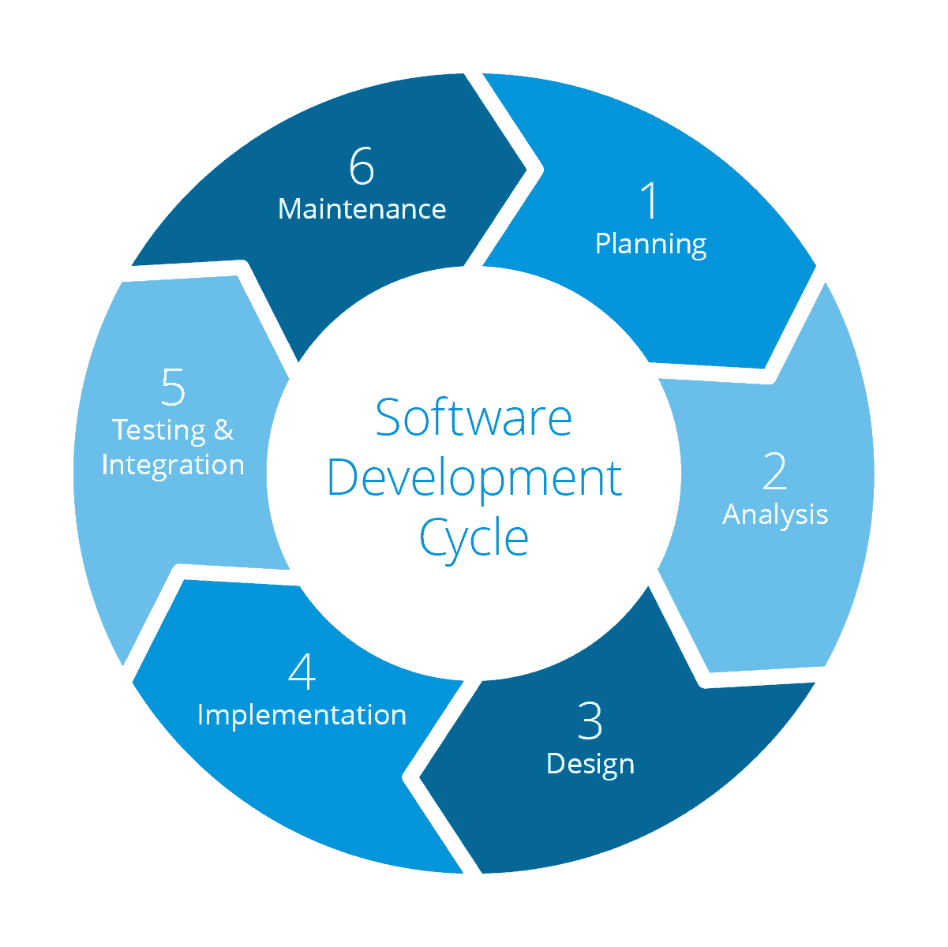

Figure 1: Software Development Lifecycle (Jasper van der Hoek, 2018).

During the analysis process, User Stories play an essential role. Being part of the Agile approach, they are composed of a sentence that expresses a scenario where the desired functionality is required (Mountain Goat Software, 2020).

In the proposed Case Study, the main functionality is expressed in 14 User Stories.

The next development process is software design. Accordingly, the application is designed using three UML Diagrams:

1. **Use Case Diagram**, a behavioural-based diagram that summarises the actions performed by the user (Visual Paradigm, 2020).
2. **Class Diagram**, a structured-based diagram that describes the attributes and operations of the classes into the system (tutorialspoint, 2020).
3. **Sequence Diagram**, an interaction-based diagram that describes how and in what order a group of objects works together in a system (Lucidchart, 2020).

To accommodate user requirements, a database is implemented to store data that needs to persist beyond the point of program termination. The EERD is used to graphically represent the Database structure and the relationships within entities.

The application is developed in C# using the Visual Studio IDE. GitHub Version Control is used to make *pair-programming* possible.

According to Matthew Heusser (2020), manually testing small novel applications by hand prove more adaptable to change and are less expensive compared to automated testing (Tomas, 2020). Thus, the application was manually tested.

The final part of the Software Lifecycle process is the Maintenance. In this respect, a list of the most important improvements was created.

## 1.4 Resources Used

The resources used by the team to create the project are:

* Draw.io, diagramming website, version 13.9.5;
* Apple Safari web browser, version 14.0 (15610.1.28.1.9, 15610);
* Google Drive version 4.2020
* Microsoft Word, version 2016 for Mac;
* Microsoft Excel version 2016 for Mac;
* Microsoft Teams version 1.3.00.28778 for Mac;
* GitHub version 2.22.0;
* Visual Studio 2019 version 16.5;

## 1.5 User Stories

Reading the HappyTech case study, it is possible to get the User Stories, whose are:

1. As a Recruiter, I want to register my data into the application so that I can get access it whenever I want.
2. As a Recruiter, I want to log into the application so that I can provide feedback for all applicants.
3. As a Recruiter, I want to enter applicant information so that I can have a list of all applicants to whom I have to give feedback to.
4. As a Recruiter, I want to select one of the available templates so that I can use it to give feedback.
5. As a Recruiter, I want all applicants and their templates from my session deleted when I logout.
6. As a Recruiter, I want to reset all applicants added so far if I do not wish to continue”.
7. As a Recruiter, I want to go back and forth through the selected templates so that I can easily check my progress.
8. As a Recruiter, I want to see all codes available to the selected template so that I can easily find and tick them if needed.
9. As a Recruiter, I want to preview specific feedback before sending emails to double-check or edit them.
10. As a recruiter, I want to abort and cancel my feedback progress if I do not wish to continue.
11. As a recruiter, I want to save feedback as a PDF and send emails in bulk.
12. As a recruiter, I want to store paragraphs of feedback in the database so that I do not need to repeatedly type the same large paragraphs.
13. As a recruiter, I want to be able to add, edit and delete codes, sections and templates so that I always have information relevant to the feedback I need to provide.
14. As a recruiter, I want easily select which sections and templates should be linked together so I can easily group related codes to the templates.

# 2. Software Design

## 2.1 Database Design

### 2.1.1 Entity Relationship Diagram

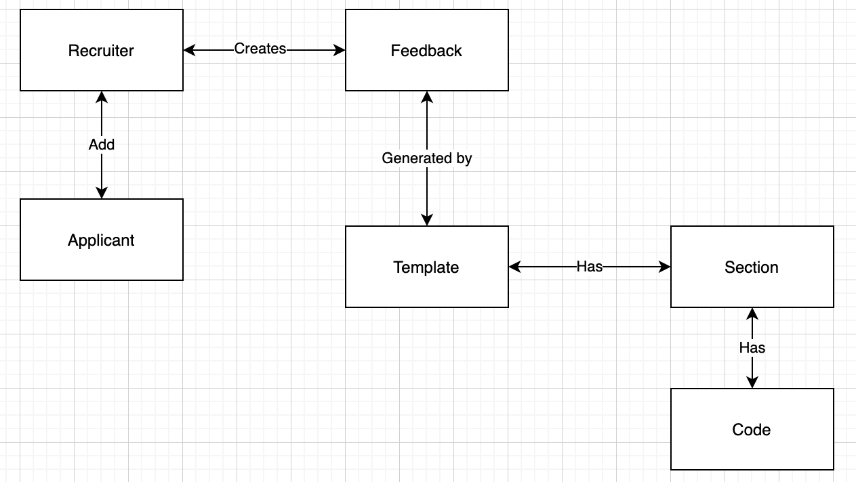

Figure 2: Entity Relationship Diagram

**Description**

In Figure 2, the ERD represents a general overview of the database structure:

* **Recruiter table** stores the information related to the user in order to keep track of who can access to the application.
* **Applicant table** stores information of the applicants who applied for a job position, which is useful to record the people interested to a certain job.
* **Feedback table** stores the feedback created. For legal purposes, it would be necessary to keep track of who gave a feedback to an applicant.
* **Template table** stores all the templates available in order to not lose all the templates every time the application is closed.
* **Section table** stores all the sections created.
* **Code** stores all the codesattached to the sections.

### 2.1.2 Extended Entity Relationship Diagram

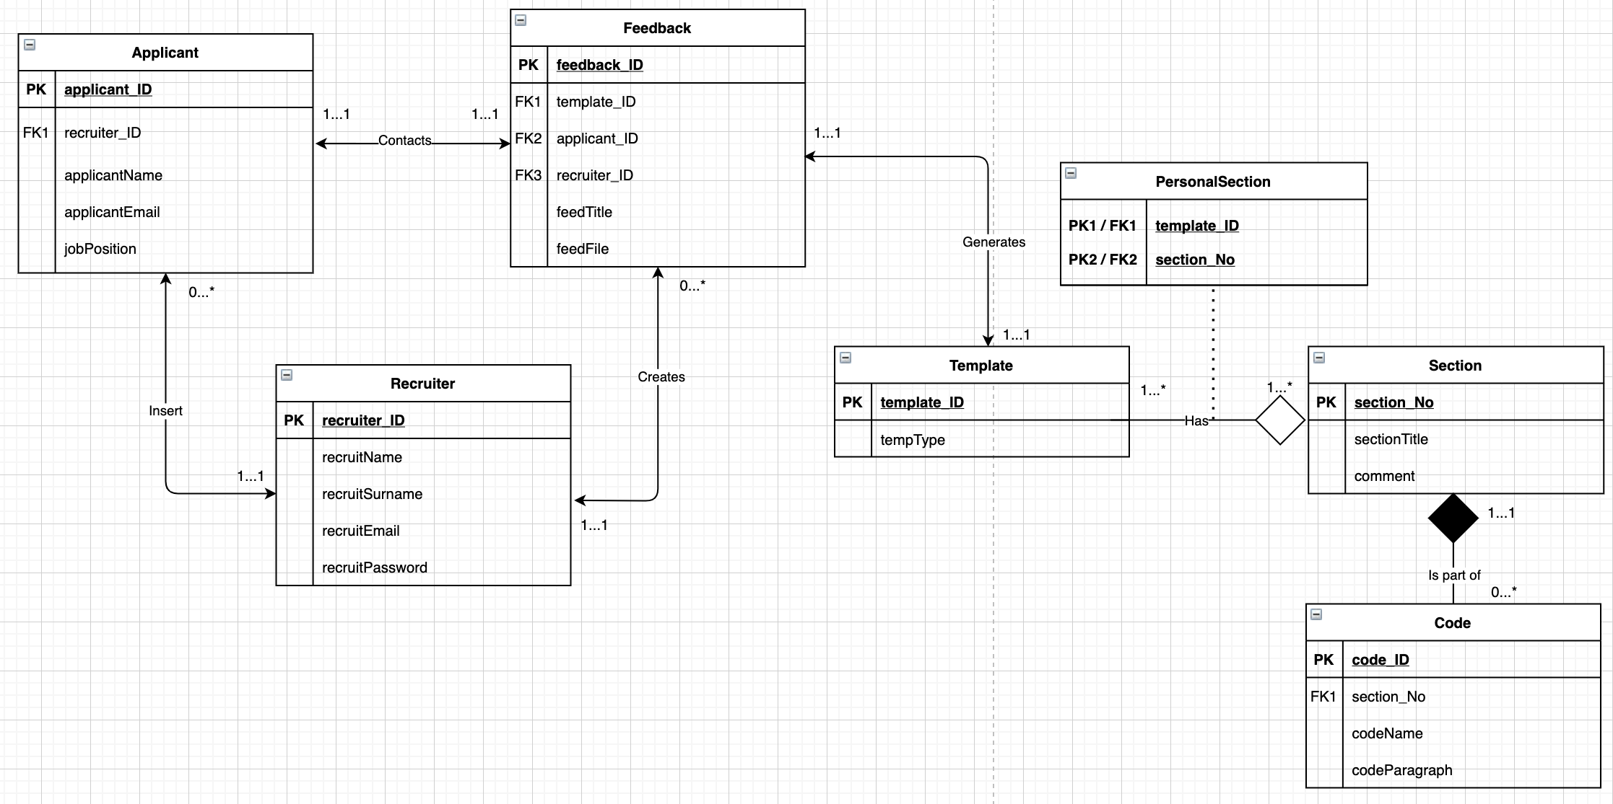

Figure 3: Extended-Entity Relationship Diagram

**Description**

As mentioned in Section1.3, a database was implemented to store data that needs to persist beyond the point of program termination. Therefore, the template table does not have neither the header nor the content. The only things required are the type (e.g. for CV, for Interview), its primary key and its sections, stored in the PersonalSection Table.

Both the header and the content will be part of the class diagram as properties of the Template Class and handled during the runtime.

In this respect, even if the recruiter can create, edit and delete a template, its table is not directly linked with the template table as it is not a requirement to keep track of who creates or amends the templates. Thus, there is no point in matching the Template_ID with the Recruiter_ID.

Aggregation relationship among Template and Section were included because if a template is deleted, its sections can still be part of other templates. Therefore, they do not have to be automatically deleted. On the other hand, since a code belongs to only one section, a Composition. relationship is required among these tables. In this respect, if a section is deleted, their codes will no longer be accessible. Therefore, they must be deleted.

### 2.1.3 Table Schema

In this section, all the entities in the database are represented in tables and each data field is defined.

|  |  |  |  |
| --- | --- | --- | --- |
| **Applicant Table** | | | |
| **Name of field** | **Data Type** | **Allow Nulls** | **Description** |
| ID | INT | No | Auto incrementing, Primary key identifier |
| Applicant_Name | NVARCHAR (50) | No | Applicant’s full name |
| Applicant_Email | NVARCHAR (50) | No | Applicant’s email |
| Job_position | NVARCHAR (50) | No | A string containing the job the applicant has applied for |
| Recruiter_id | INT | Yes | A Foreign Key to the Recruiter table to link the Applicant and which recruiter dealt with their application. Allowed Null because Applicants may be made in the system before a Recruiter is assigned to them. |

|  |  |  |  |
| --- | --- | --- | --- |
| **Recruiter Table** | | | |
| **Field Name** | **Data Type** | **Allow Nulls** | **Description** |
| Id | INT | No | Auto-incrementing primary key. |
| Name | NVARCHAR (50) | No | String for the recruiter’s first name |
| Surname | NVARCHAR (50) | No | String for the recruiter’s last name. |
| Email | NVARCHAR (50) | No | String to store the recruiter’s email. Used to log in |
| Password | NVARCHAR (50) | No | String to store the recruiter’s password. Also used to log in. |

|  |  |  |  |
| --- | --- | --- | --- |
| **Feedback Table** | | | |
| **Field Name** | **Data Type** | **Allow Nulls** | **Description** |
| ID | INT | No | Primary key, auto incrementing |
| Template_ID | INT | No | Would have linked 1 feedback object to a row in the Template table |
| Applicant_ID | INT | No | Would have linked 1 feedback object to a row in the Applicant Table |
| feedFile | NVARCHAR (8000) | No | Would have contained the text that made up the feedback document |
| feedTitle | NVARCHAR (100) | No | Stores the title of the feedback document |
| Recruiter_ID | INT | No | The FK to the recruiter table of the recruiter who generated the feedback. |
| Comment | NVARCHAR (500) | No | Stores a string containing any additional comments the recruiter has |

|  |  |  |  |
| --- | --- | --- | --- |
| **Template Table** | | | |
| **Field Name** | **Data Type** | **Allow nulls** | **Comment** |
| Id | INT | No | Auto-increment primary key |
| tempType | NVARCHAR (50) | No | String to store the type of document that feedback is being provided on. (short for template type) |

|  |  |  |  |
| --- | --- | --- | --- |
| **PersonalSection Table** | | | |
| **Field Name** | **Data Type** | **Allow Nulls** | **Comment** |
| Template_ID | INT | No | FK to a row on the Template table. |
| Section_ID | INT | No | FK to a row on the section table |

|  |  |  |  |
| --- | --- | --- | --- |
| **Section Table** | | | |
| **Field Name** | **Data Type** | **Allow nulls** | **Comment** |
| Id | INT | No | Auto-increment primary key |
| Name | NVARCHAR (50) | No | String to store the name of the section |

|  |  |  |  |
| --- | --- | --- | --- |
| **Code Table** | | | |
| **Name** | **Data Type** | **Allow Nulls** | **Comment** |
| ID | INT | No | Primary key, auto incrementing |
| codeShort | NVARCHAR (50) | No | Short version of the comment. |
| SectionNo | INT | No | FK to the section table. Links comments to 1 section object |
| codeParagragh | NVARCHAR (300) | No | This is the paragraph to be added to the feedback form when the short code is clicked on. |

## 2.2 UML Design Diagrams

### 2.2.1 Use Case Diagram

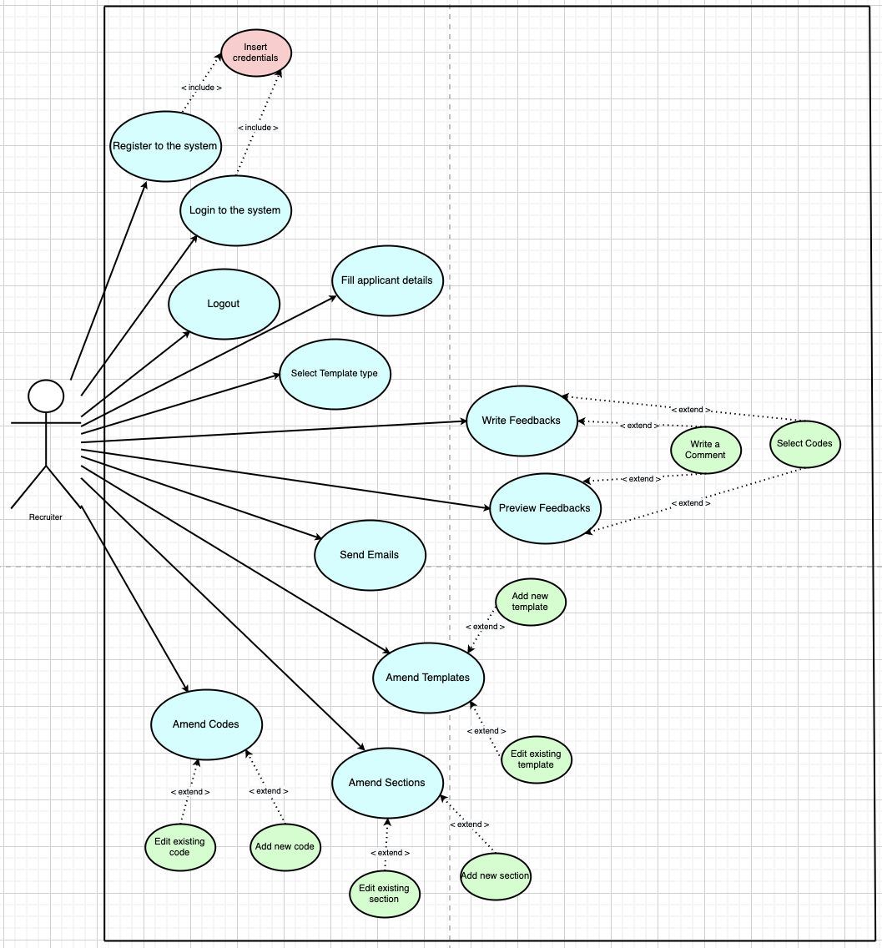

Figure 4: UML Use Case Diagram

**Description**

|  |  |
| --- | --- |
| **Use Case Name** | Register to the System |
| **Actors** | Recruiter |
| **Flow of Events** | 1. User clicks on the “Create Account” button; 2. Registration Page opens; 3. User fills in his details; 4. User clicks on the “Create” button; 5. Confirmation message is displayed. |
| **Alternative Flows** | 3a. Error message displays: “fields must be 50 characters or less”;  3b. Error message displays: “Email must use @happytech.com”;  3c. Error message displays: “password must be at least 8 characters”;  4a. Email already exists in the system. Thus, User cannot create the account;  4b. Fields are empty, an error message is displayed  5a. No Confirmation message, the user returns to the login page. |
| **Entry Conditions** | User has an email belonging to happytech. |
| **Exit Conditions** | User either successfully registers into the system or cancels the registration |

|  |  |
| --- | --- |
| **Use Case Name** | Login to the system |
| **Actors** | Recruiter |
| **Flow of Events** | 1. User fills in his details; 2. User clicks on the login button; 3. Dashboard page opens; |
| **Alternative Flows** | 2a. Error message displays: “Incorrect email or password”;  3a. Dashboard does not open;  4. User clicks on “Create Account” button. |
| **Entry Conditions** | User has credentials |
| **Exit Conditions** | User either enters correct credentials or cancels the login |

|  |  |
| --- | --- |
| **Use Case Name** | Logout |
| **Actors** | Recruiter |
| **Flow of Events** | 1. User clicks on the Logout button; 2. Message displays: “Are you sure?”; 3. User clicks on it again and comes back to the Login page. |
| **Alternative Flows** | 3a. The user changes his mind and he does not double click. |
| **Entry Conditions** | User is on the dashboard |
| **Exit Conditions** | User either logs out or gives up the logging out |

|  |  |
| --- | --- |
| **Use Case Name** | Fill applicant details |
| **Actors** | Recruiter |
| **Flow of Events** | 1. User fills in the applicant details; 2. User clicks on “Save button”. |
| **Alternative Flows** | 2a. Error message displays: “fields must be 50 characters or less”;  2b. Fields are empty, an error message is displayed. |
| **Entry Conditions** | User is on the dashboard |
| **Exit Conditions** | User correctly inserts details or gives up filling applicant details |

|  |  |
| --- | --- |
| **Use Case Name** | Select template type |
| **Actors** | Recruiter |
| **Flow of Events** | 1. User Clicks on one of the available templates; 2. Templates is confirmed and its fields becomes blue. |
| **Alternative Flows** | 1a. There are no templates, an error message is displayed;  1aa. User clicks on the “Editor” button; |
| **Entry Conditions** | User is on the dashboard |
| **Exit Conditions** | User correctly select one template or gives up filling applicant details |

|  |  |
| --- | --- |
| **Use Case Name** | Write feedback |
| **Actors** | Recruiter |
| **Flow of Events** | 1. User clicks some of the available codes; 2. User writes a comment; 3. User clicks on the “Next” button to move the next applicant. |
| **Alternative Flows** | 3a. User clicks on the “Back” button to go back to the previous applicant; |
| **Entry Conditions** | User is on the feedback page |
| **Exit Conditions** | User provides feedback for all the applicants or give up writing feedback |

|  |  |
| --- | --- |
| **Use Case Name** | Preview feedback |
| **Actors** | Recruiter |
| **Flow of Events** | 1. User clicks on one of the created feedback; 2. User clicks on the “Preview” button; 3. User amends the fields previously inserted. 4. User clicks on the “Next” button and amends are saved |
| **Alternative Flows** | 4a. User clicks on the “Back” button sand the changes are deleted |
| **Entry Conditions** | User is on the preview feedback page |
| **Exit Conditions** | User is sure about the feedback created |

|  |  |
| --- | --- |
| **Use Case Name** | Send Emails |
| **Actors** | Recruiter |
| **Flow of Events** | 1. User clicks on the “Send All” button; 2. System displays successful message; 3. System creates a PDF of all the feedback created; 4. User comes back to the dashboard. |
| **Alternative Flows** | 1.1. User clicks on the “Cancel” button;  1.2. Message displays: “Are you sure?”;  1.3. User clicks on it again and comes back to the dashboard. |
| **Entry Conditions** | User is on the summary feedback page |
| **Exit Conditions** | User reviewed the generated PDFs goes back to the dashboard |

|  |  |
| --- | --- |
| **Use Case Name** | Amend templates |
| **Actors** | Recruiter |
| **Flow of Events** | 1. Add a template name; 2. Add section (optional); 3. Clicks on “Save” button; 4. Message displays the successful outcome; 5. Click on “Back” button; 6. System goes back to the main editor page. |
| **Alternative Flows** | 1a. Edit a template name;  3a. Clicks on “Cancel” button to erase the fields;  3b. Clicks on “Delete” button to erase the template from the database; |
| **Entry Conditions** | User is on the Editor page |
| **Exit Conditions** | User is happy with the amends done |

|  |  |
| --- | --- |
| **Use Case Name** | Amend sections |
| **Actors** | Recruiter |
| **Flow of Events** | 1. Add a section name; 2. Add to template (optional); 3. Clicks on “Save” button; 4. Message displays the successful outcome; 5. Click on “Back” button; 6. System goes back to the main editor page. |
| **Alternative Flows** | 1a. Edit a section name;  3a. Clicks on “Cancel” button to erase the fields;  3b. Clicks on “Delete” button to erase the section from the database; |
| **Entry Conditions** | User is on the Editor page |
| **Exit Conditions** | User is happy with the amends done |

|  |  |
| --- | --- |
| **Use Case Name** | Amend codes |
| **Actors** | Recruiter |
| **Flow of Events** | 1. Add a code name; 2. Add a code paragraph; 3. Add to section; 4. Clicks on “Save” button; 5. Message displays the successful outcome; 6. Click on “Back” button; 7. System goes back to the main editor page. |
| **Alternative Flows** | 1a. Edit a code name;  2a. Edit a code paragraph  4a. Clicks on “Cancel” button to erase the fields;  4b. Clicks on “Delete” button to erase the section from the database; |
| **Entry Conditions** | User is on the Editor page |
| **Exit Conditions** | User is happy with the amends done |

### 2.2.2 Class Diagram

Figure 5 presents the initial Class Diagram, created prior the implementation on Visual Studio.

Based on the requirements, the diagram is composed by 10 classes: 5 Front-End classes and 5 Back-End classes.

The Forms include methods needed to perform the actions defined in the user stories such as FillCodeList() in Feedback Form or EditTemplate() and EditSection() in Editor Form.

Applicant, Recruiter, Template, Code and Section contains almost the same properties stored in the database, plus methods needed to get and set them.

Additionally, all the classes have a constructor which is executed whenever a new object is created.

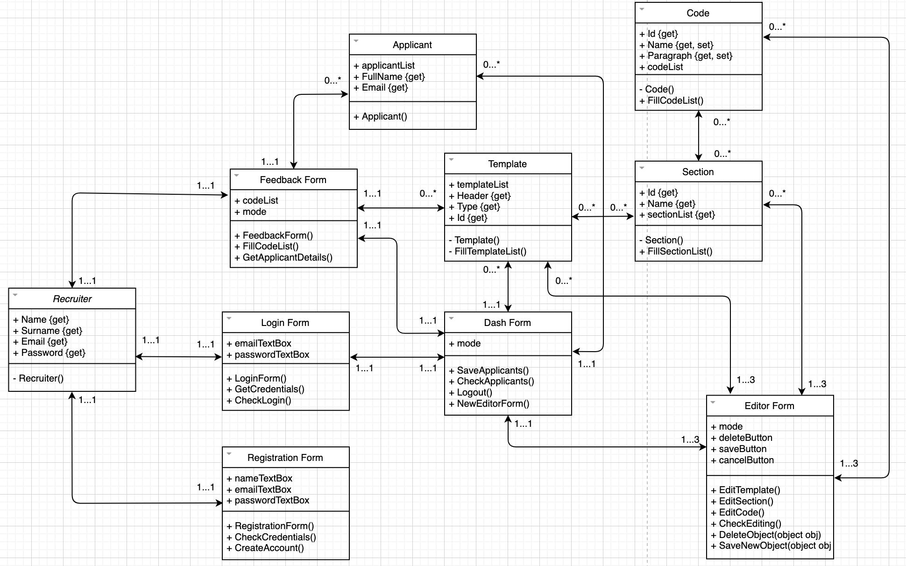

Figure 5: Initial UML Class Diagram

In Figure 6, the final Class Diagram brief presents the relationships between classes, which are explained in Figure 7.

As the implementation progresses, the diagram becomes complex just like the complete Class Diagram represented in Figure 8.

In this respect, it represents all the objects created in the Forms such as buttons, textboxes and DataGridViews.

As mentioned in Section 1.3, the aim of the Class Diagram is to understand the general structure of the system. Thus, the Class Diagram is usually created prior the implementation and it should be understandable.

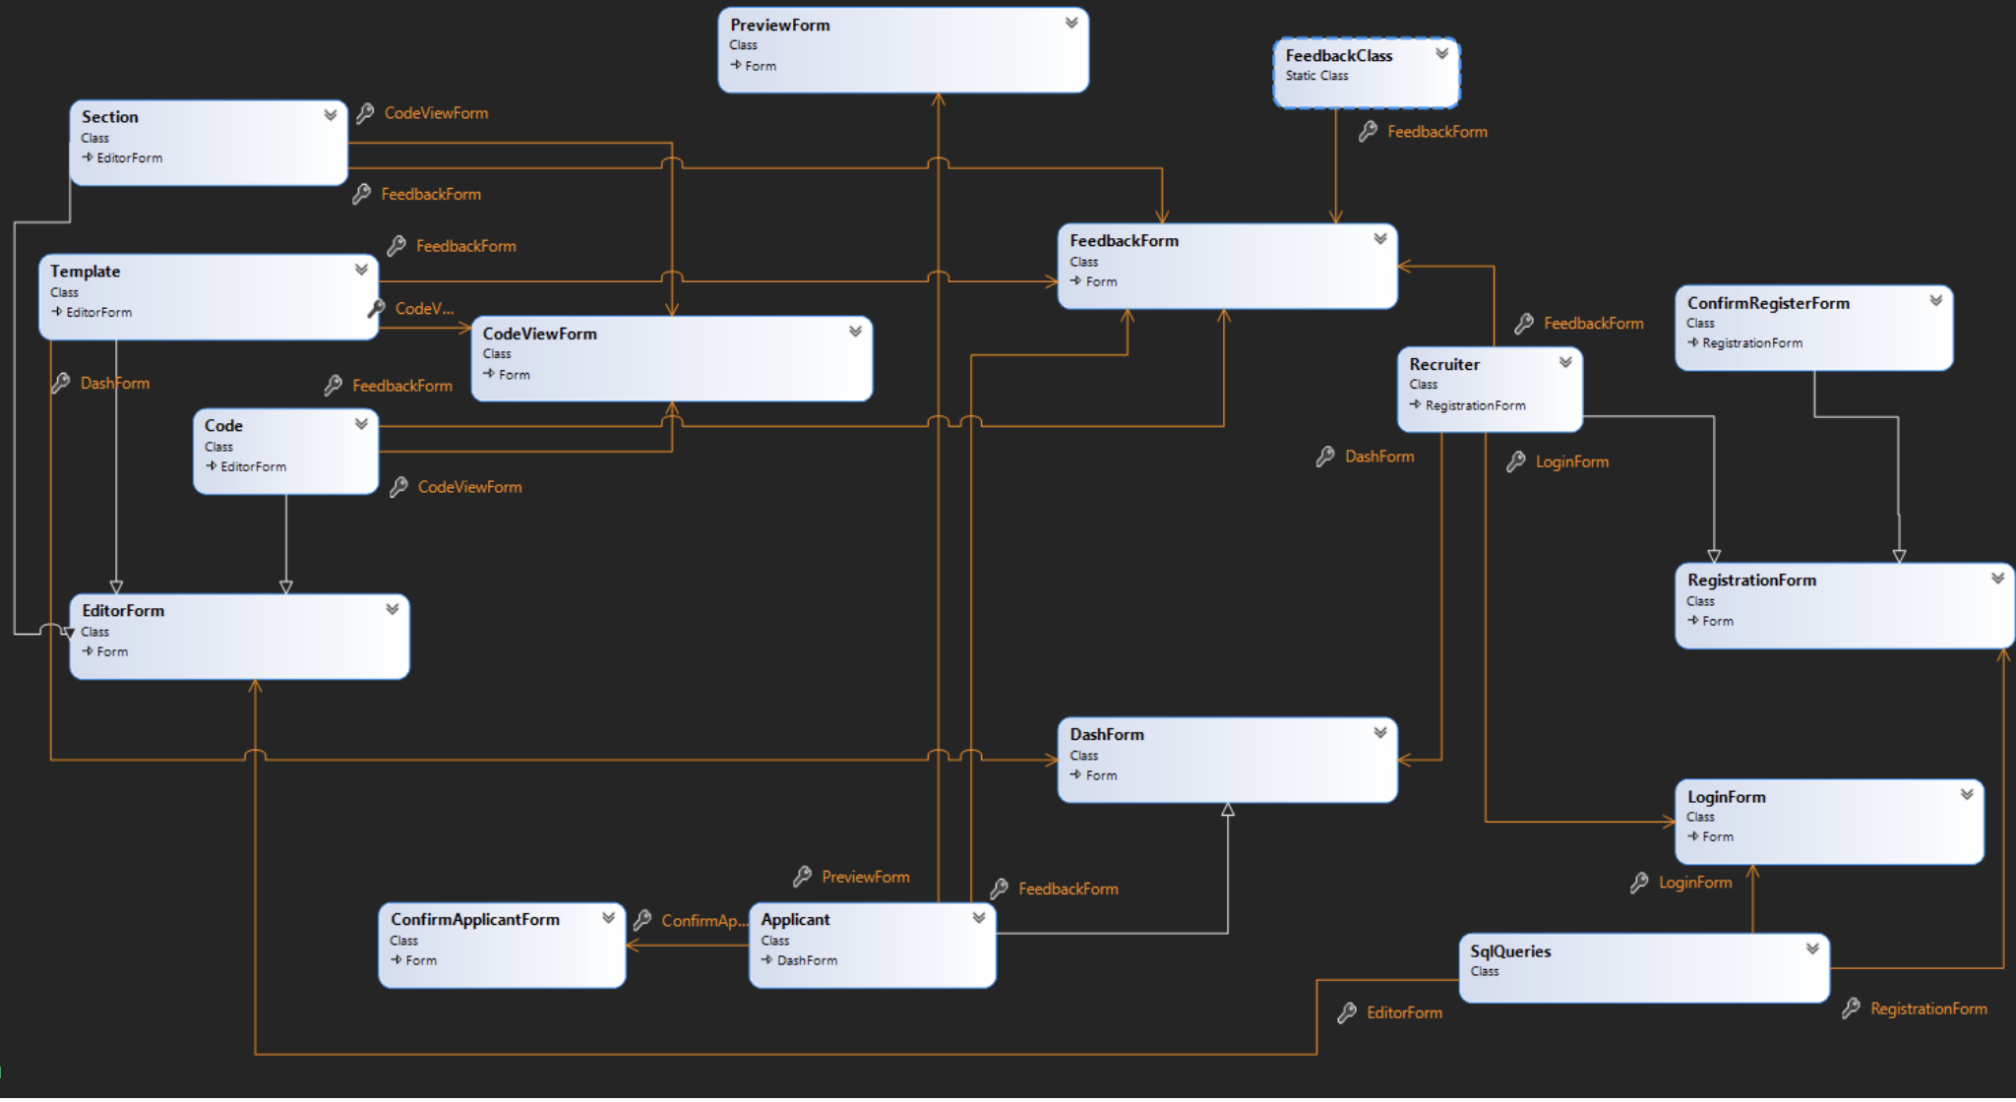

Figure 6: UML Class Diagram Brief from Visual Studio

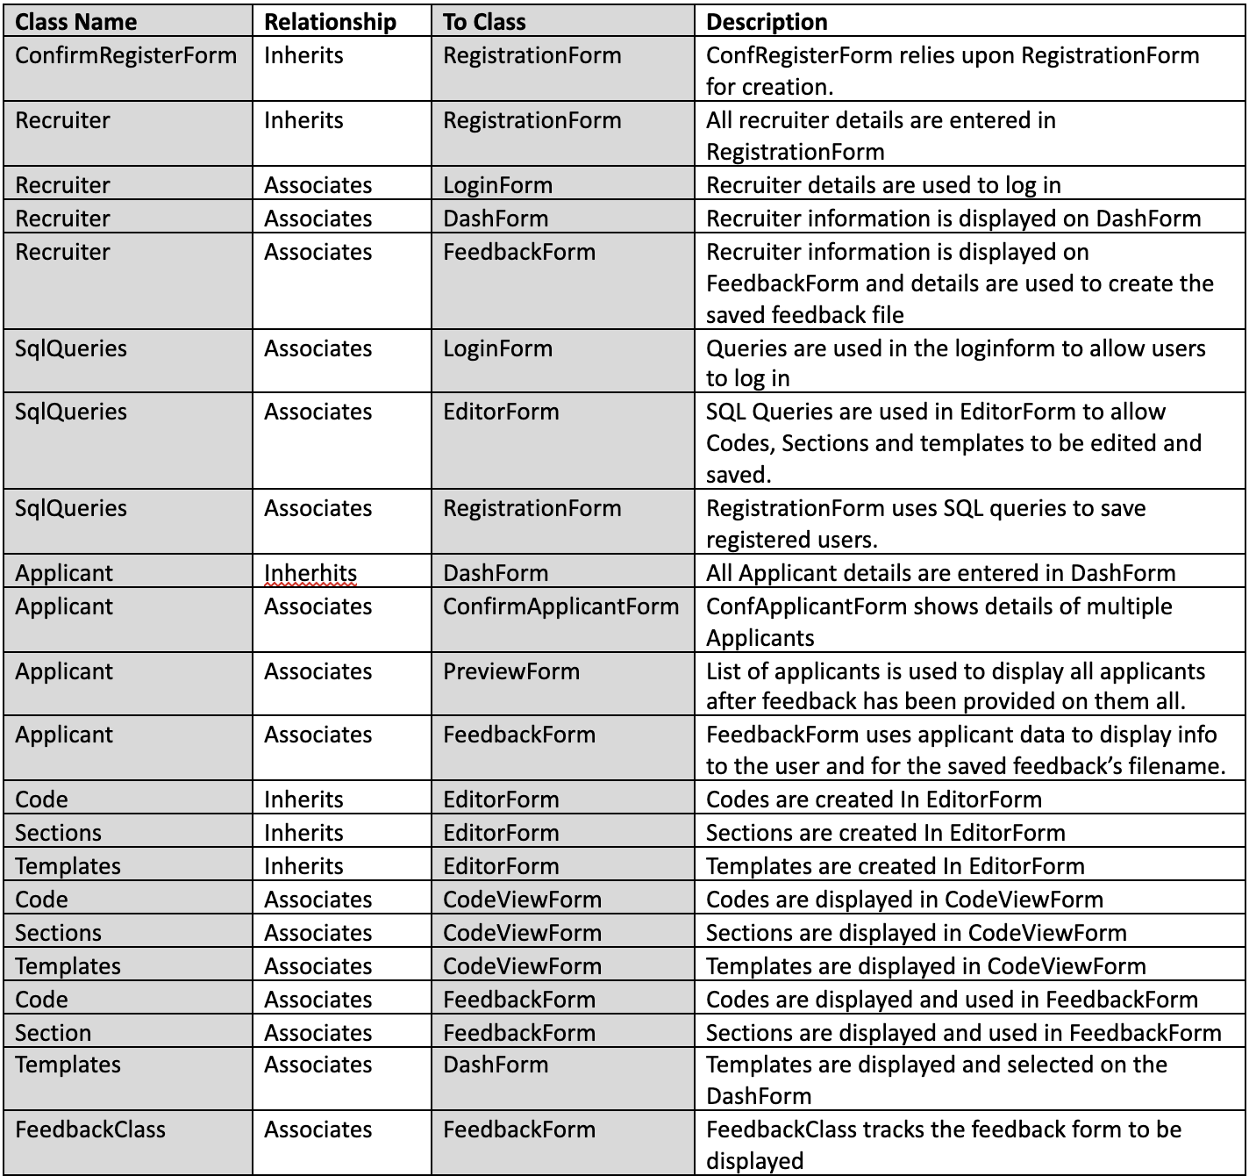

Figure 7: Relationships Schema

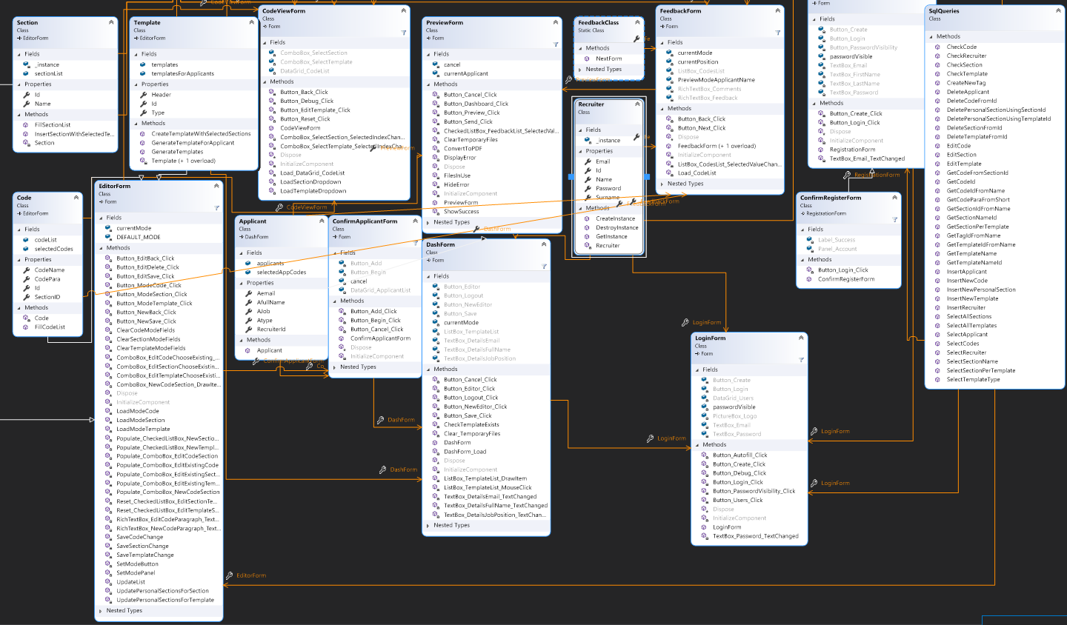

Figure 8: Complete UML Class Diagram from Visual Studio

### 2.2.3 Sequence Diagrams

* **User Story 1:** In Figure 9, the diagram displays the action of registering in the system:

1. The user inserts the credentials: first name, last name, email and password;
2. Registration form checks whether the details are correct;
3. If they are correct, the system calls the method in SqlQueries class to retrieve the query which enables the system to insert the details into the system;
4. The system displays the confirmation message.

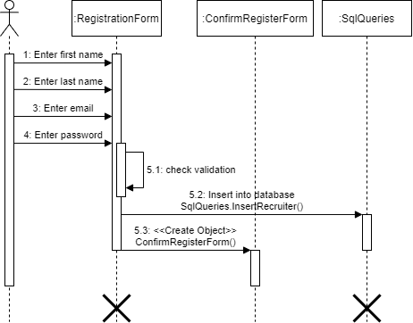

Figure 9: Registering in the system

* **User Story 2:** In Figure 10, the diagram represents the action of logging in the system:

1. The user enters email and password;
2. Login Form checks whether the fields inserted exists in the system;
3. If yes, it creates the recruiter instance within its class;

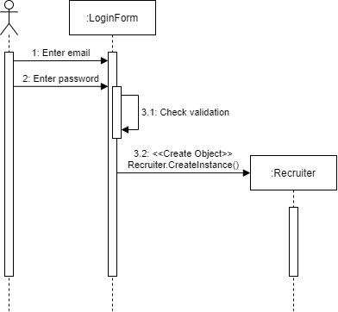

Figure 10: Logging in the system

* **User Story 3 / 4:** In Figure 11, the user enters the applicant details and selects the templates:

1. User enters the applicant details and select one of the available templates;
2. The system checks for the information validation;
3. If yes, the system creates a new applicant and adds it into the list;
4. The system inserts the details into the database;
5. The system displays the ConfirmApplicantForm.

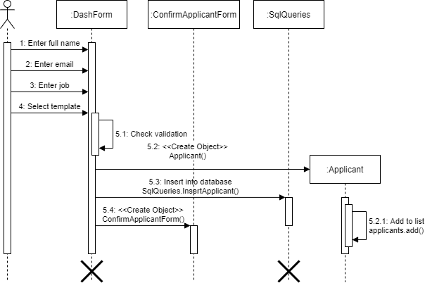

Figure 11: Enters applicant details and template

* **User Story 5:** In Figure 12, the diagram represents the action of logging out from the system:

1. User press log out button;
2. The system destroys the recruiter instance, deletes applicants from the database and clears both applicants and template lists;
3. The system displays the LoginForm.

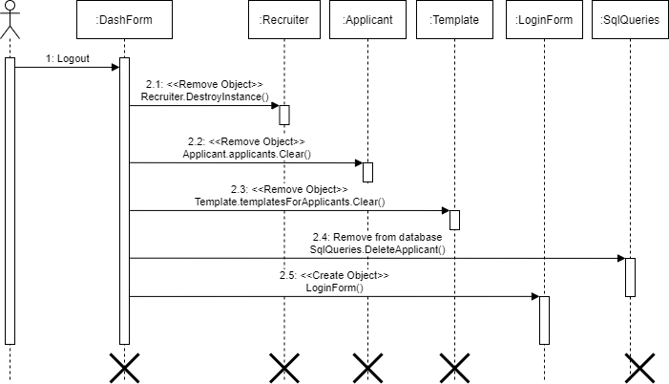

Figure 12: Logging out from the system

* **User Story 6 / 10:** In Figure 13-14, the user wants to reset the progresses done so far:

1. The user clicks on the Abort button;
2. The system displays a new dashboard in default mode;
3. The system deletes applicants from the database and clears both applicants and template lists;

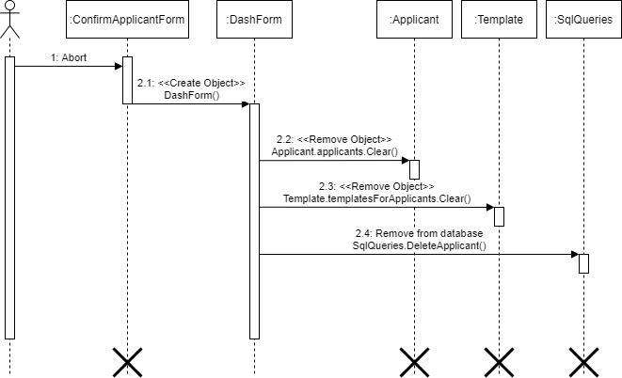

Figure 13: Reset progresses from ConfirmApplicantForm

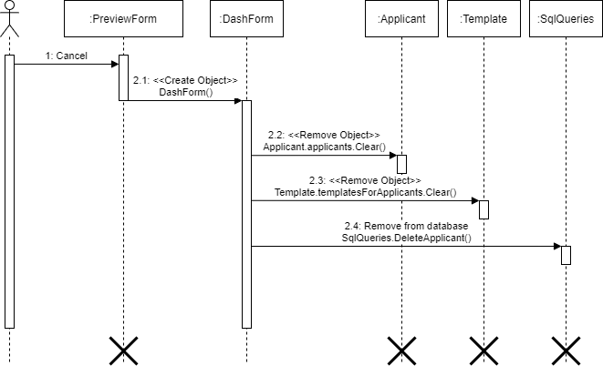

Figure 14: Reset progresses from PreviewForm

* **User Story 7:** In Figure 15, the user iterates through the templates in the list:

1. The user clicks on next button;
2. The system saves the current session in an RTF file and displays the next form using the Feedback Class;
3. The user clicks on the back button;
4. The system displays the previous form using the Feedback Class.

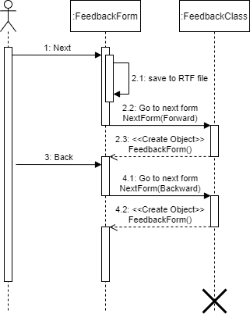

Figure 15: Iterating through templates

* **User Story 8:** In Figure 16, the user selects the available codes when creating the feedback:

1. The user selects one of the available codes;
2. The system clears both the selectedCodes and selectedAppCodes lists;
3. The system clears the feedback box, update the codes and fill the feedback box again;
4. The system adds the selected code to both the selectedCodes and selectedAppCodes lists;

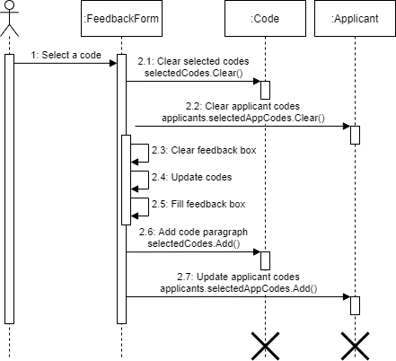

Figure 16: Selecting codes

* **User Story 9:** In Figure 17, the user previews the feedback created:

1. The user selects one of the created feedback to preview;
2. The system gets the applicant belonging to the feedback and checks for files errors.
3. The system displays the feedback form in preview mode;
4. The user clicks on the back button to go back to the Preview Form.

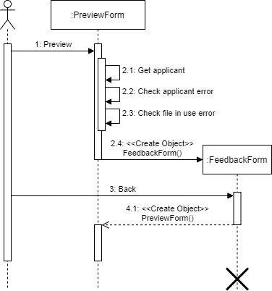

Figure 17: Previewing feedback

* **User Story 11:** In Figure 18, the user saves feedback a PDF files:

1. User clicks on the Send all button;
2. The system converts the files to PDF, clears the RTF files and shows the successful message;
3. The system returns a new Dash Form.

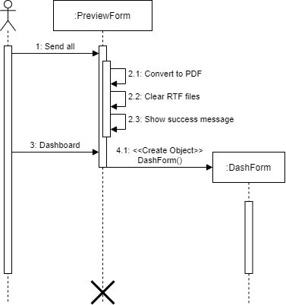

Figure 18: Saving feedback as PDFs

* **User Story 12:** In Figure 19, the user creates a new code:

1. User opens the Editor Form and select the code mode;
2. The system displays the code page;
3. User types both name and paragraph and clicks on the save button;
4. The system inserts the details into the database;
5. The system clears and updates the textboxes and reloads the combo box.

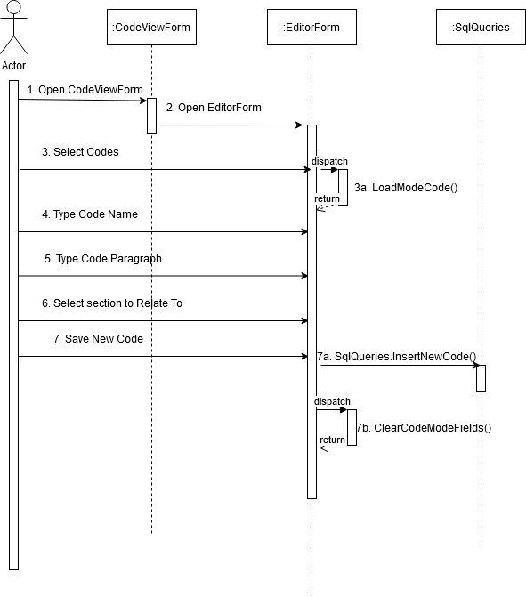

Figure 19: Creating new codes

* **User Story 13:** In Figure 20, the user edits an existing code:

1. User opens the Editor Form and select the code mode;
2. User select one of the existing items in the drop-down list;
3. Through the Section class, the system retrieves the code paragraph attached to the selected code name from the database;
4. The system fills in the Edit boxes with the code name, code paragraph and its code section;
5. The user clicks on the delete button;
6. The system deletes the data in the database and clears the textboxes and reloads the combo box.

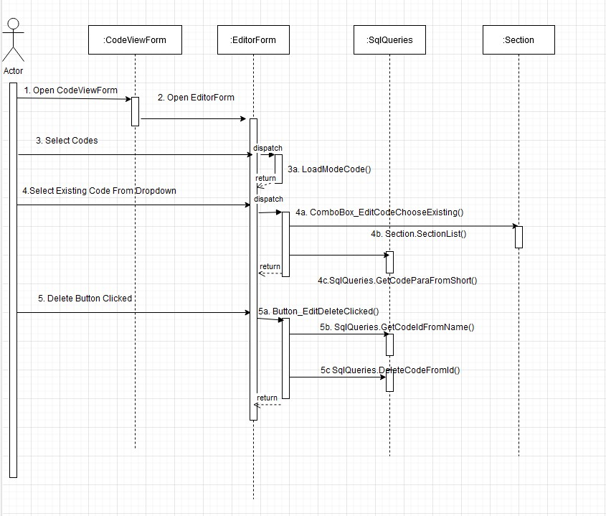

Figure 20: Editing an existing code

* **User Story 14:** In Figure 21, the user adds sections to a template:

1. User opens the Editor Form and select the template mode;
2. User select one of the existing items in the drop-down list;
3. Through the Section class, the system retrieves the sections attached to the template;
4. The user selects the desired sections and clicks the save button;
5. The system, through the Editor Form and Section class, saves the changes into the database, clears the textboxes and reloads the combo box.

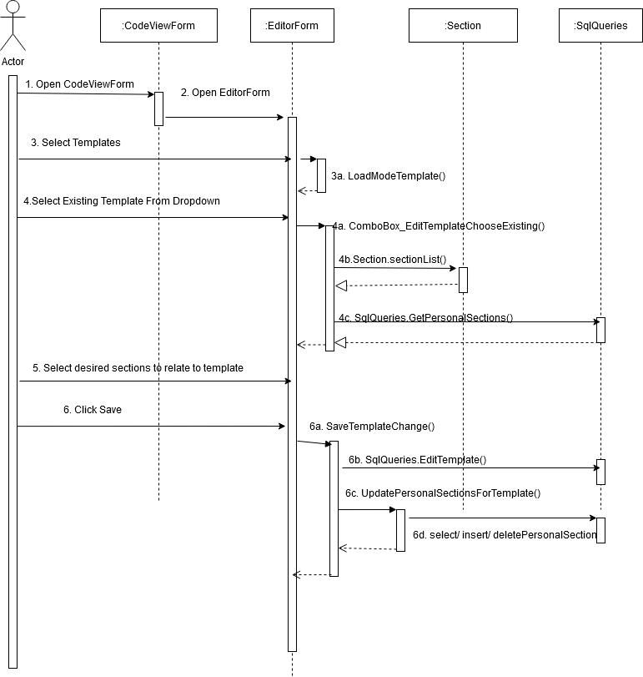

Figure 21: Adding sections to templates

# 3. Software Development Documentation

## 3.1 Personal User Stories

### 3.1.1 User Story 1

***“As a Recruiter, I want to register my data into the application so that I can get access it whenever I want.”***

**Description**

From the registration form (Figure 22), the recruiter is able to insert his credentials: First Name, Last Name, Email and Password.

If he already has an account, he can be redirected to the login page using the login button.

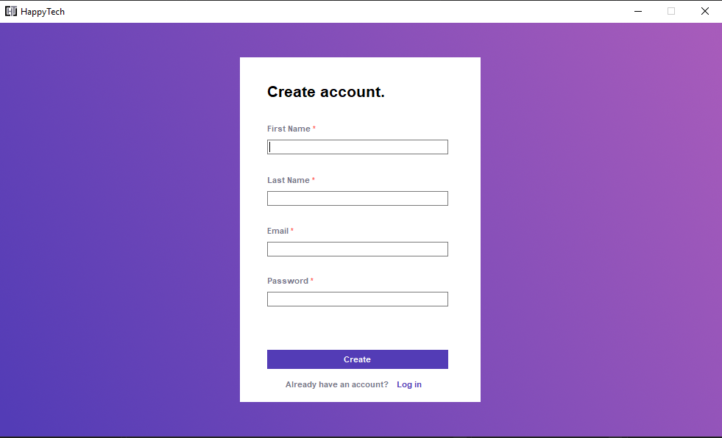

Figure 22: Registration Page

All the implemented checks are displayed from Figure 23 to Figure 30:

* In Figure 23, it makes sure that the user inserted all the information required.

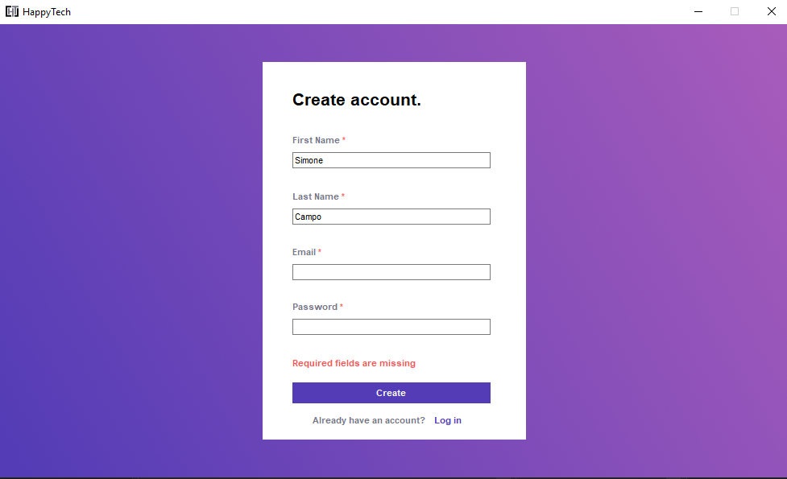

Figure 23: Email and Password missing

* In Figure 24, it checks whether the email inserted has the company domain, which is @happytech.com.

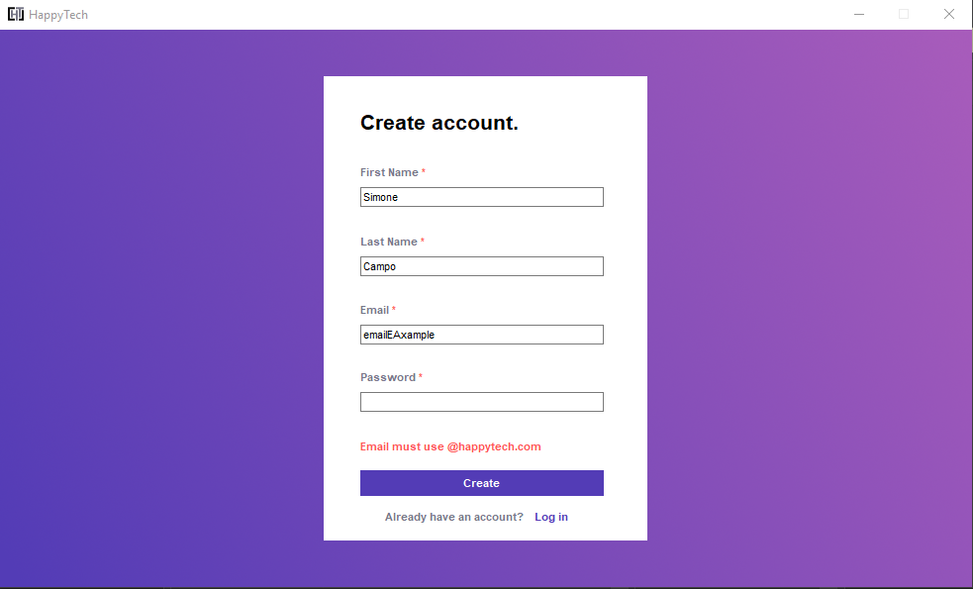

Figure 24: Wrong email inserted

* In Figure 25, it ensures that the password is composed by at least 8 characters.

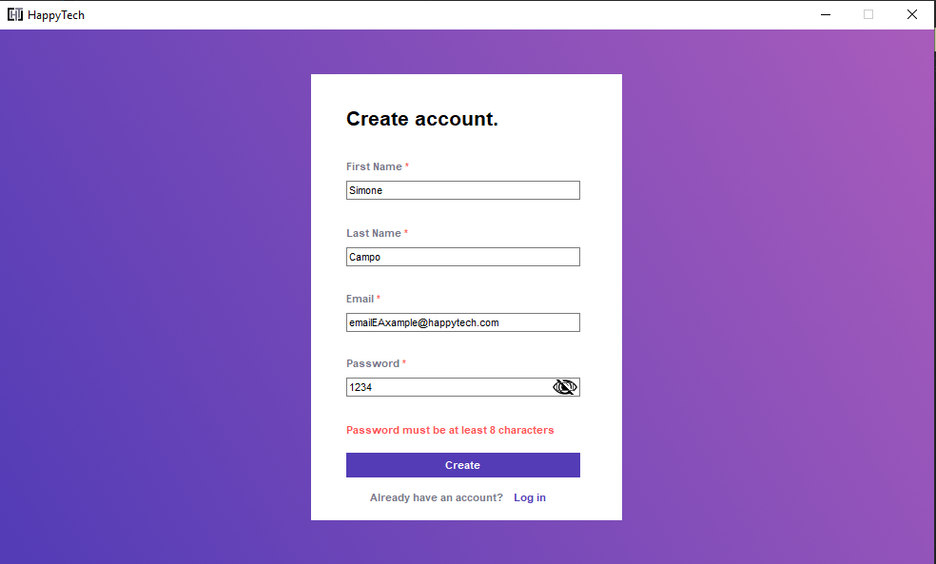

Figure 25: Password too short

* From Figure 26 to Figure 29, it makes sure that all the fields do not exceed 50 characters, as it would be the maximum amount stored by the database.

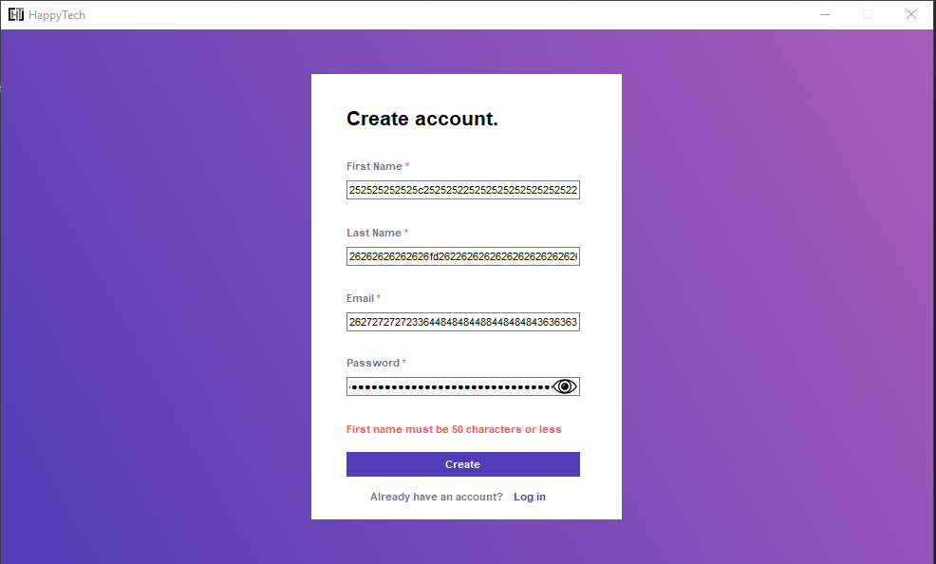

Figure 26: First Name too long

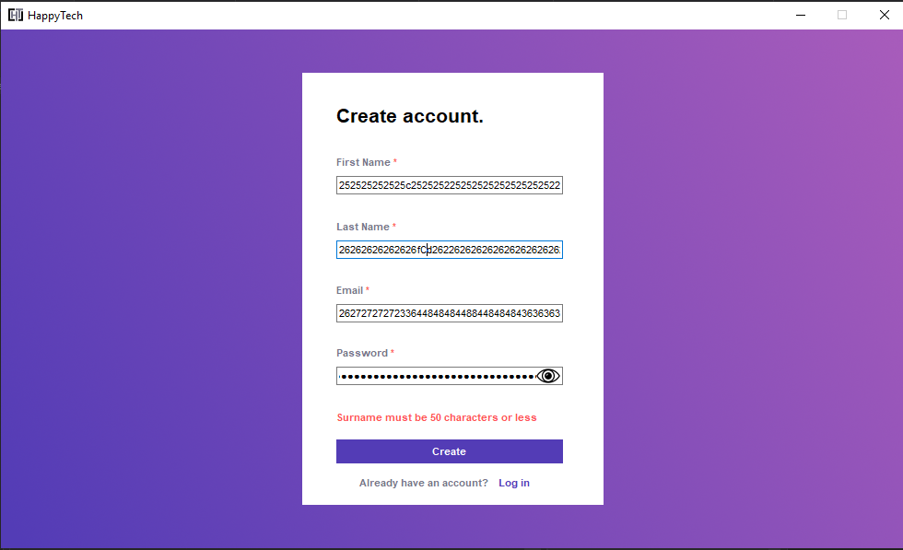

Figure 27: Last name too long

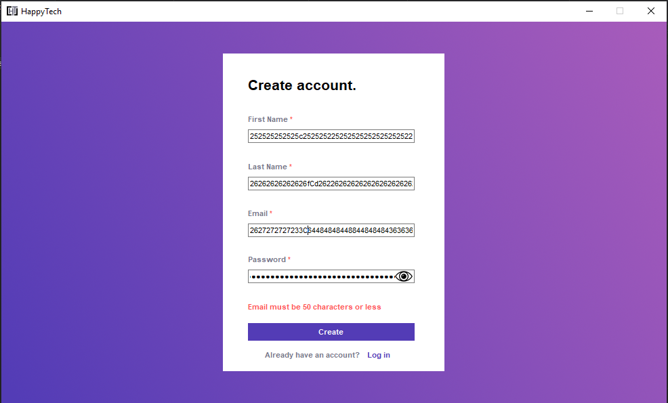

Figure 28: Email too long

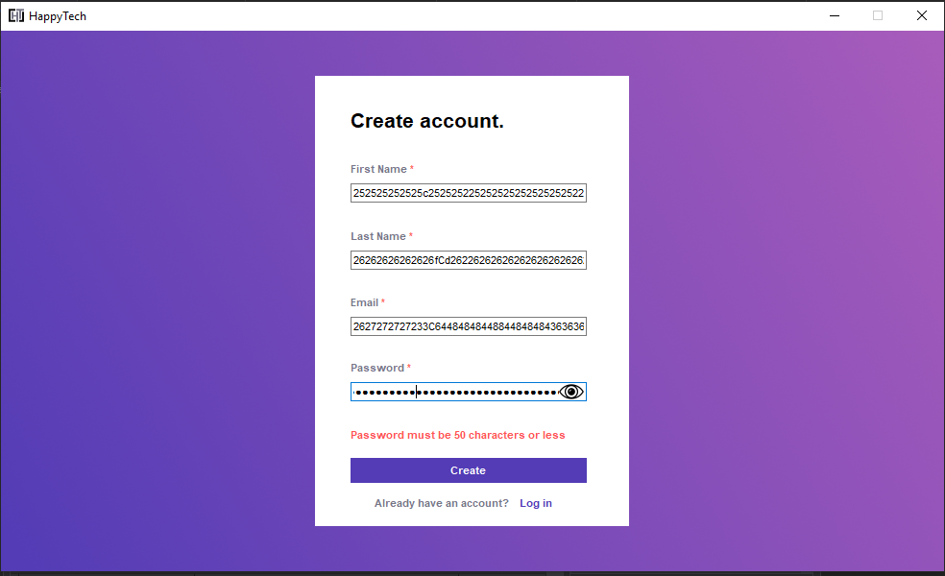

Figure 29: Password too long

In Figure 30, the final check ensures that the email provided does not already exists, otherwise the user has already registered into the system.

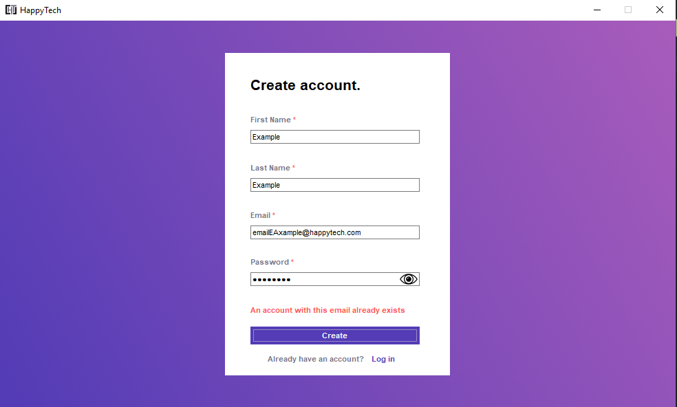

Figure 30: Account already exists

If all the checks pass, the recruiter is able to create its own account (Figure 31). Therefore, he can be redirected to the login page using the green button.

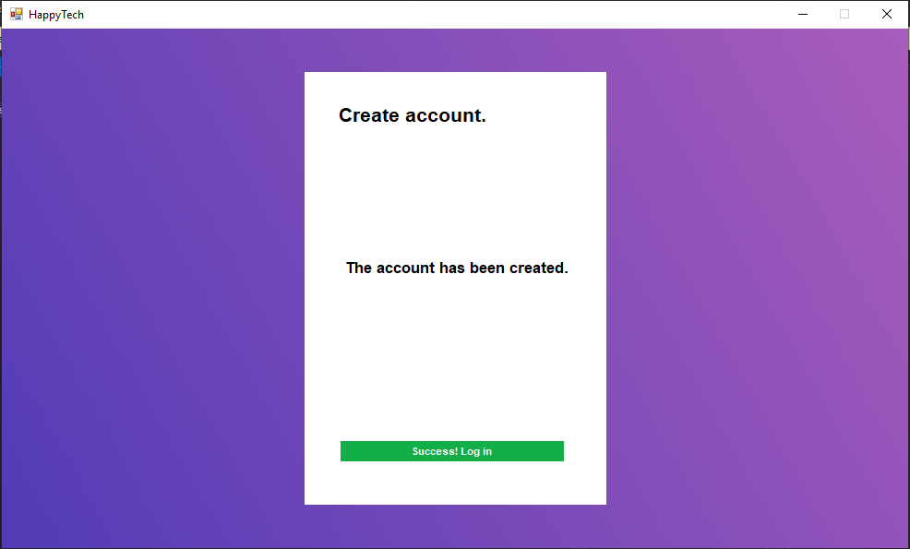

Figure 31: Confirm Registration Page

### 3.1.2 User Story 2

***“As a Recruiter, I want to log into the application so that I can provide feedback for all applicants.”***

**Description**

In Figure 32, the main page allows the recruiter to either login into the system by inserting the credentials or to create an account if he has not already created one yet.

**Note:** the “debug” button is for testing purposes as it shows all the recruiters stored in the database. Therefore, it will be not presented into the commercial version.

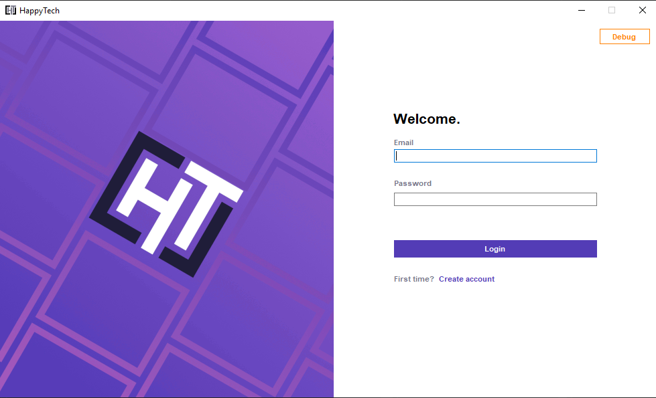

Figure 32: Login Page

For security purposes, in Figure 33 the ‘eye button’ has been implemented. Its aim is to allow the user to see the password inserted, which is displayed in black dots by default.

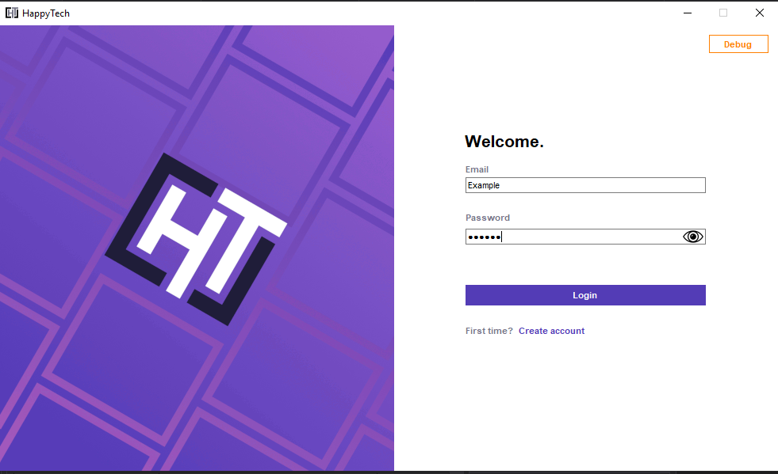

Figure 33: Credentials filled

When the recruiters clicks on the Login button, the systems checks whether the details are correct and, if not, an error message is displayed (Figure 34).

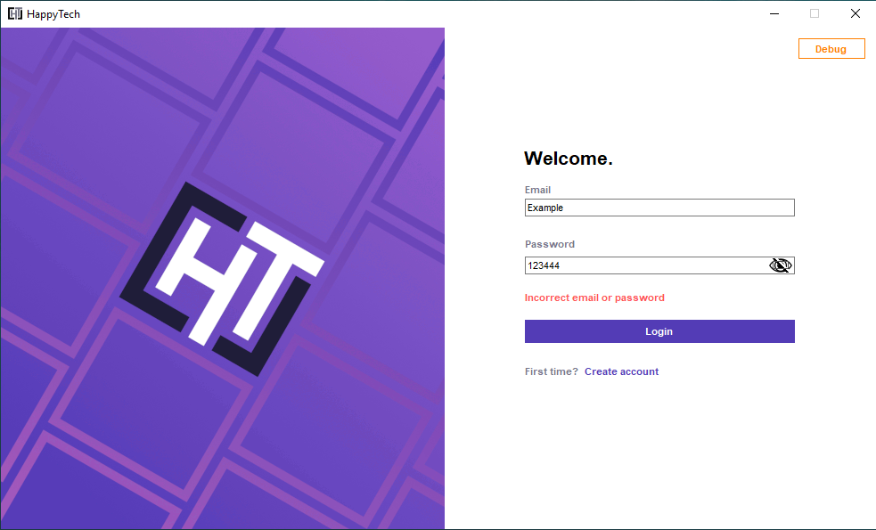

Figure 34: Wrong credentials

### 3.1.3 User Story 3 & 4

***“As a Recruiter, I want to enter applicant information so that I can have a list of all applicants to whom I have to give feedback to.”***

***“As a Recruiter, I want to select one of the available templates so that I can use it to give feedback.”***

**Description**

In Figure 35, the dashboard comes out as soon as the recruiter logs into the system. From here, it is possible to fill in the details of a single applicant as well as the template required to create the feedback.

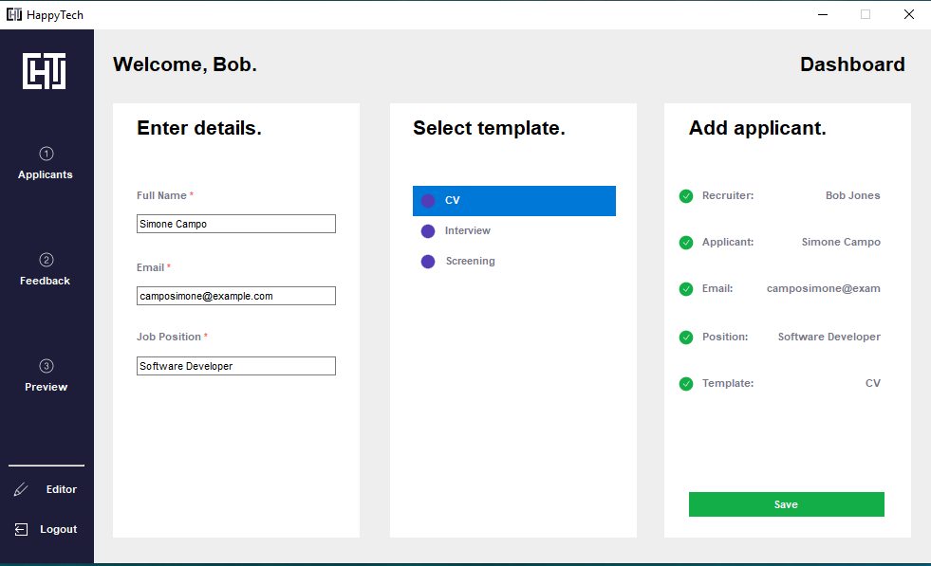

Figure 35: Dashboard: Adding applicants and template

When saving the information, two checks are performed:

* The first one, makes sure the fields do not exceed 50 characters, as it would be the maximum amount stored by the database (Figure 36).

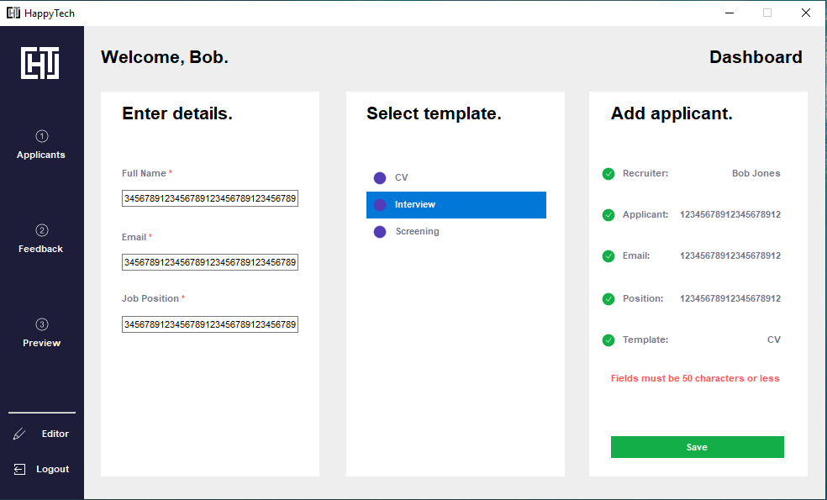

Figure 36: Fields too long

* The second one, checks whether all the fields have been inserted (Figure 37).

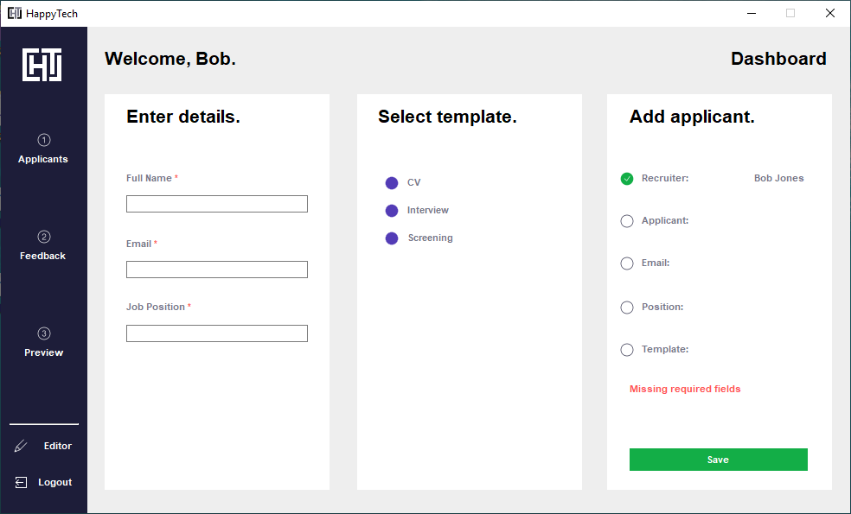

Figure 37: No fields inserted

If everything goes fine, the list of the current applicants is displayed and the user can add the next applicant (Figure 38).

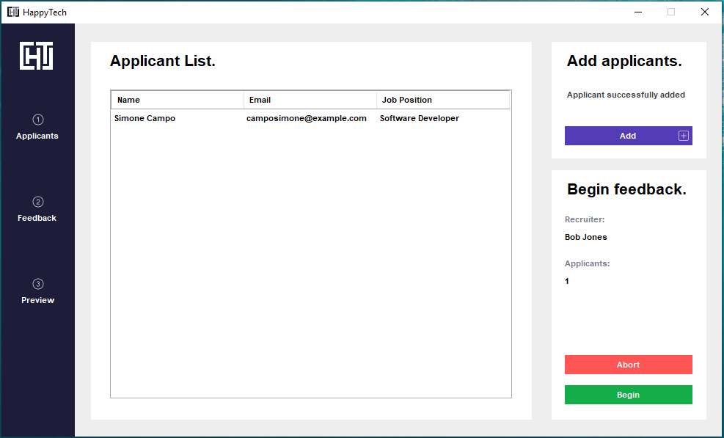

Figure 38: Confirm Applicant Details page

Note that, when the user decides to add the next applicant, the ‘Cancel’ button appears. It allows the user to go back to the previous window and to continue with the applicants already inserted (Figure 39).

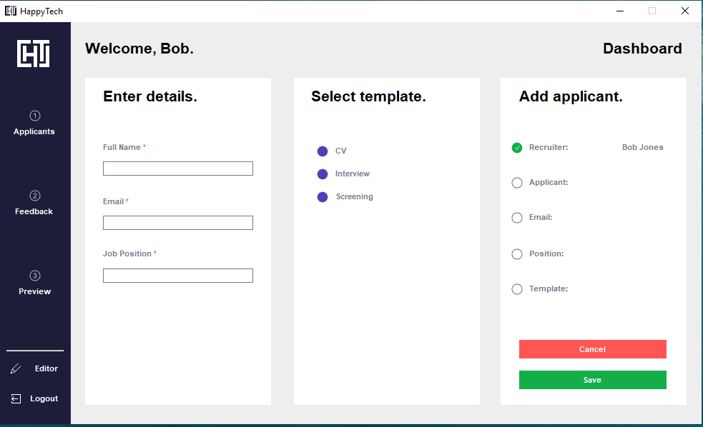

Figure 39: Adding a new applicant

### 3.1.4 User Story 5

***“As a Recruiter, I want all applicants and their templates from my session deleted when I logout.”***

**Description**

In Figure 40, the dashboard page allows also the user to log out from the system. Indeed, when the logout button is clicked, a double check displays the message “Are you sure?”. If it is clicked for the second time, the user goes back to the login page.

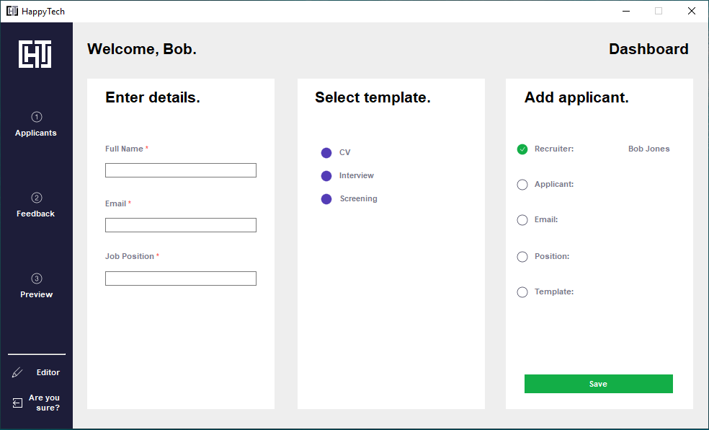

Figure 40: Logout change text at the bottom left

### 3.1.5 User Story 6

***“As a Recruiter, I want to reset all applicants added so far if I do not wish to continue.”***

**Description**

In Figure 41, it is possible to either delete all the applicants inserted, coming back to the dashboard or to begin writing the feedback.

Since cancel button may result in a loss of data, it works as the Logout button described in Section 4.4.1.

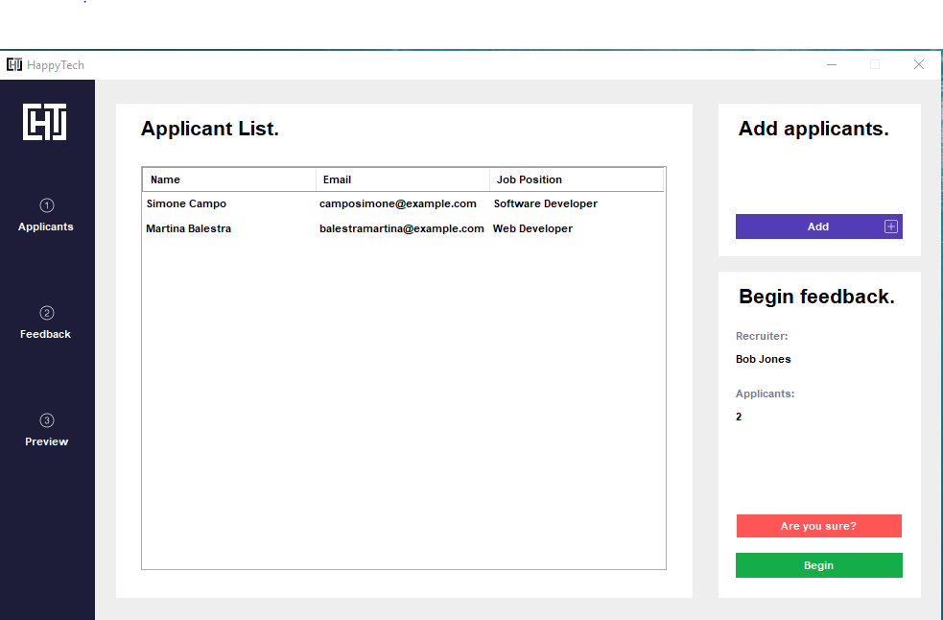

Figure 41: Abort button change

### 3.1.6 User Story 7 & 8

***“As a Recruiter, I want to go back and forth through the selected templates so that I can easily check my progress.”***

***“As a Recruiter, I want to see all codes available to the selected template so that I can easily find and tick them if needed.”***

**Description**

In Figure 42, the Feedback page is composed by four main parts:

* **Codes List:** holds all the codes belonging to the sections, which relate to the template chosen;
* **Template:** holds the paragraphs of all the selected codes. Then, it turns into feedback once completed;
* **Comments:** holds an additional comment which can be written by the recruiter;
* **Details:** shows the number of the applicant in the list and the information related information.

There are two more buttons which allow the user to iterate through all the applicants in the list.

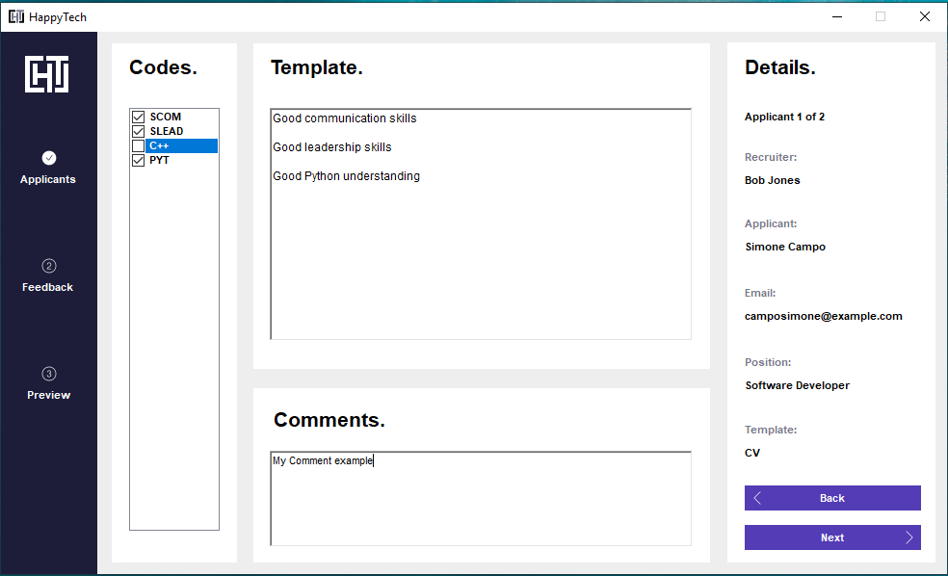

Figure 42: Applicant 1: Selecting codes and adding comment

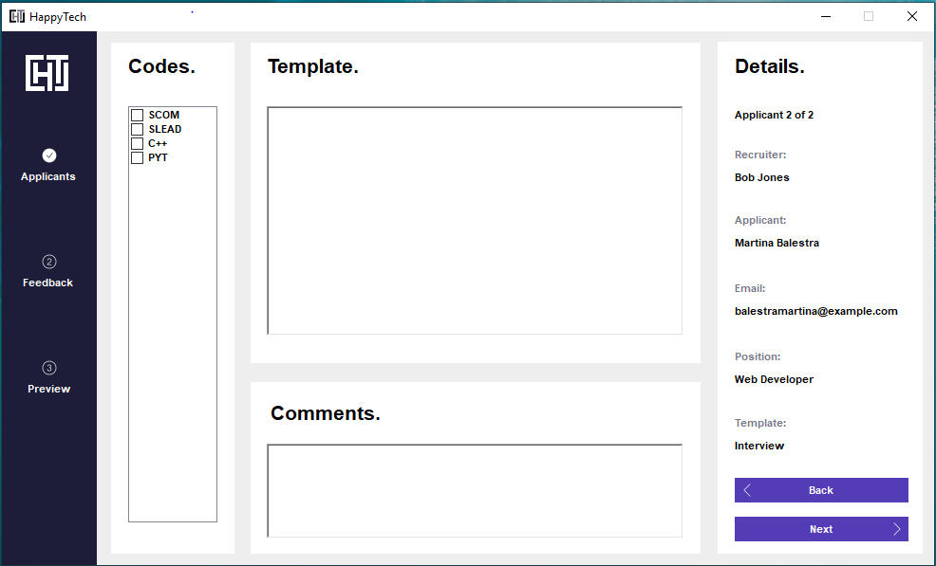

Figure 43: Applicant 2 page

## 3.2 Personal Implementations

### 3.2.1 Front-End Classes

**RegistrationForm**

In Figure 44, the author created the if statements, which are used to check whether the fields inserted by the recruiter are correct. Additionally, the author created a method in “*SqlQueries*” back-end class that returns a string containing the query to ask the database for.

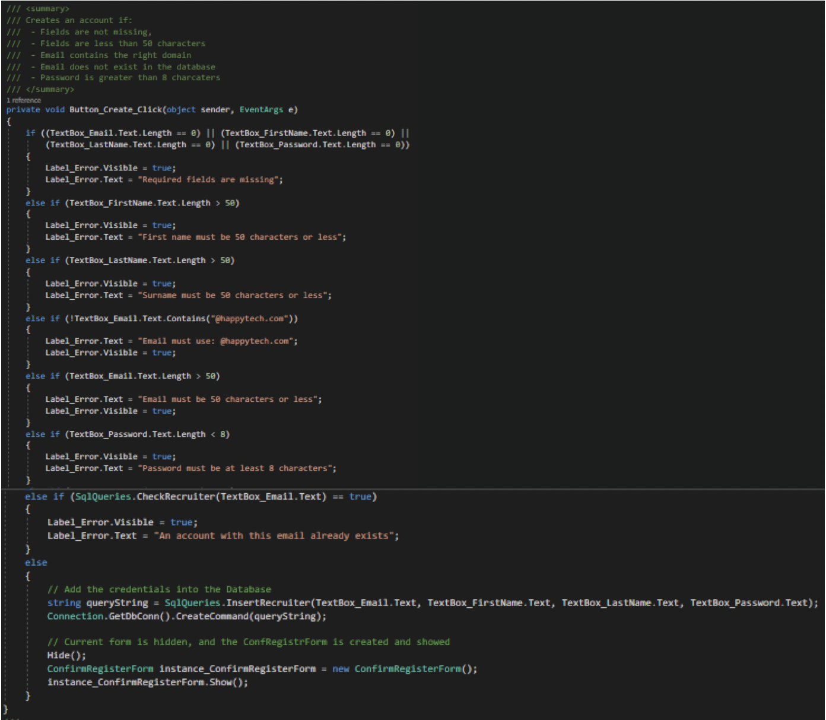

Figure 44: Button_Create_Click()

The method in Figure 45, was implemented by the author in order to allow the user to go back to the LoginForm.

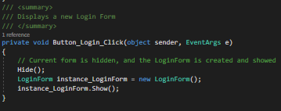

Figure 45: Button_Login_Click()

In Figure 46, the author fixed the code indentation and improved the if statements (e.g. ‘TextBox_Password.Text == “”’ becomes ‘TextBox_Password.Text.Length == 0’).

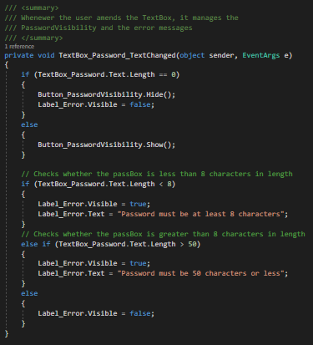

Figure 46: TextBox_Password_TextChanged()

The method in Figure 47, was enhanced by the author, who applied the same improvements as the “TextBox_Password_TextChanged()” method.

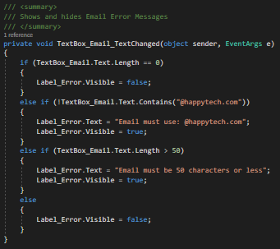

Figure 47: TextBox_Email_TextChanged()

In Figure 48, the method was enhanced by the author with the same improvements as the “TextBox_Password_TextChanged()” method.

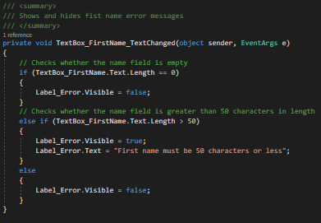

Figure 48: TextBox_ FirstName_TextChanged()

The method in Figure 49 was enhanced by the author, who applied the same improvements as the “TextBox_Password_TextChanged()” method.

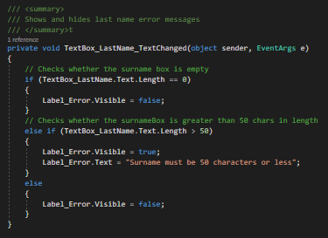

Figure 49: TextBox_LastName_TextChanged()

**ConfirmRegisterForm**

The Form in Figure 50 was created by the author, who wanted to display the registration outcome in a dedicated page.

In previous versions, the author used the form to also inform the user if the email inserted already existed in the system. However, it was changed by one of the team members, who preferred to implement the error message in the RegistrationForm.

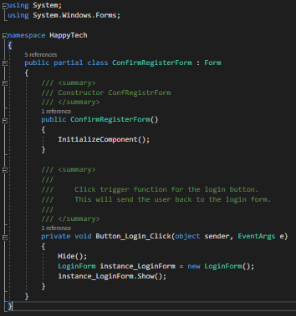

Figure 50: ConfirmRegisterForm()

**LoginForm**

In Figure 51, the author introduced both the if statement and the DataRow class to retrieve values from the database in order to create the recruiter instance.

Additionally, the author created the method in SqlQueries class with the aim to separate the SQL from the front-end class.

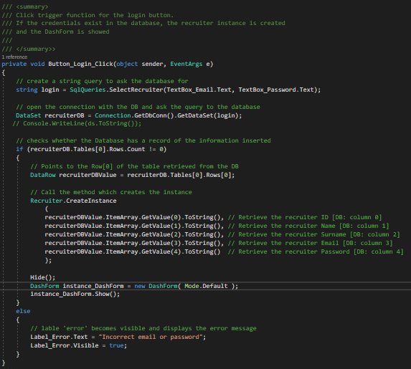

Figure 51: Button_Login_Click()

The method in Figure 52 was implemented by the author and it creates a new registration page.

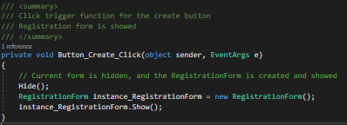

Figure 52: Button_Create_Click()

**DashForm**

The following Form was created by the author and enhanced within the other team members’ help.

In Figure 53, the constructor was fully created by the author, who implemented the connection with the database to retrieve the templates from the database and the switch statement which:

* When the applicant list is not empty, it makes the Button_Cancel visible;
* When the mode is set to ‘Default’, it deletes the applicants from the database and from the list.

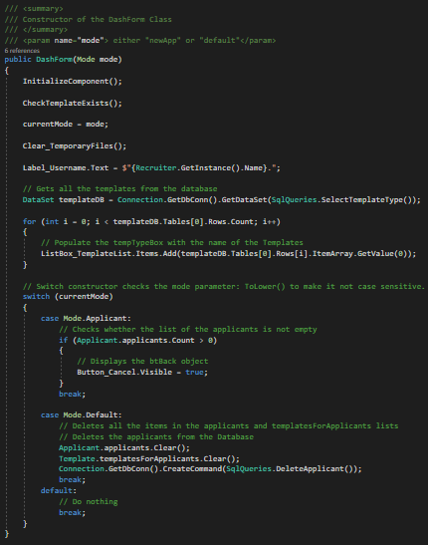

Figure 53: DashForm()

The method in Figure 54 was created by the author, who implemented both the if statement to double check the intention of logging out by the user and the methods to delete applicants and templates.

The author also created a method which cleans both the applicant and template lists and deletes the applicants from the database. This method was called in both Button_Logout_Click method and DashForm constructor, inside the switch statement. However, it has been erased by one of the team members.

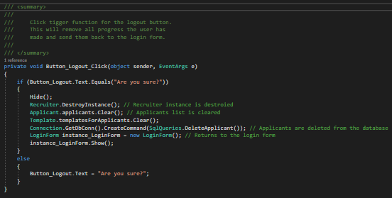

Figure 54: Button_Logout_Click()

The method in Figure 55 was created by the author: when the list is not empty, it enables the user to go back to the ConfirmApplicantForm.

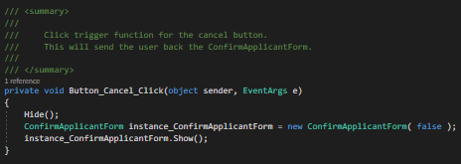

Figure 55: Button_Cancel_Click()

The method in Figure 56 was fully created by the author, who created the if statements to check whether a template is chosen and textboxes are not empty and less than 50 characters in length. Additionally, the author created the connection and the method in SqlQueries class in order to add the applicant in the database.

Furthermore, the author called the applicant and template constructors as well as the methods to add them inside the pre-created lists.

At the end, the ConfirmApplicantForm is created and displayed.

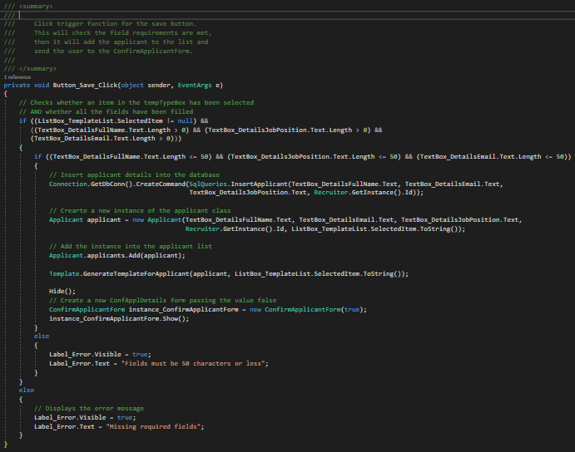

Figure 56: Button_Save_Click()

**ConfirmApplicantForm**

The following form was created by the author and enhanced within the team members’ help.

The author implemented the method in Figure 57, which aim is to show the successful message and the number of applicants added. The author also implemented the database connection required to populate the DataGrid_ApplicantList with the applicant details.

The author assigned values in both Label_RecruiterName and Label_ApplicantTotal.

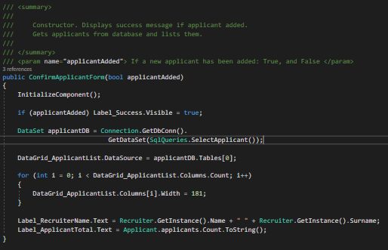

Figure 57: ConfirmApplicantForm()

The author created the method in Figure 58 that enables the user to go back to the DashForm in order to add another applicant into the list.

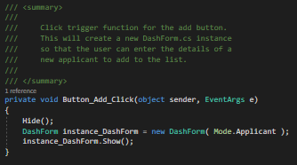

Figure 58: Button_Add_Click()

The method in Figure 59 was created by the author in order to enable the recruiter to start writing feedback.

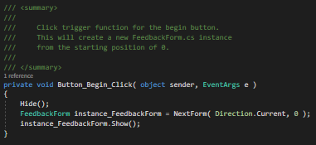

Figure 59: Button_Begin_Click()

The method in Figure 60 enables the user to cancel all the applicants inside the project. While it was created by the author, the enhancements were applied by other team members.

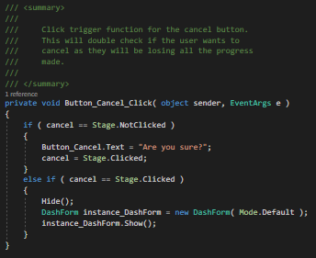

Figure 60: Button_Cancel_Click()

**FeedbackForm**

The following form was created by the author and enhanced with the other team members’ help.

Within the constructor, the author designed the form in a way that it takes the information related to both the current applicant in the list and the templated selected for the feedback. The index in the list is handled by the “position” variable.

In previous versions, the author also displayed the template header containing the information requested by the requirements. While the template’s header is still a property of its class, it has been deleted in the current method by one of the team members in favour of a new form design.

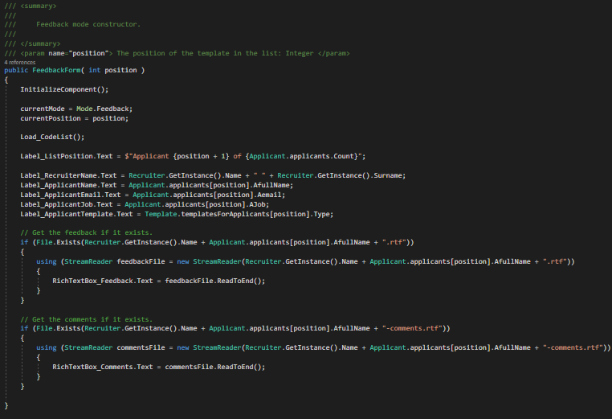

Figure 61: FeedbackForm()

The methods in Figures 62-63, were created by the author, with the aim to handle the iteration between templates in the list. While the the Button_Back_Click() retrieves the previous template, the Button_Next_Click() retrieves the following one.

Additionally, the author created both the if statements used to check whether the templates they are attempting to get exist.

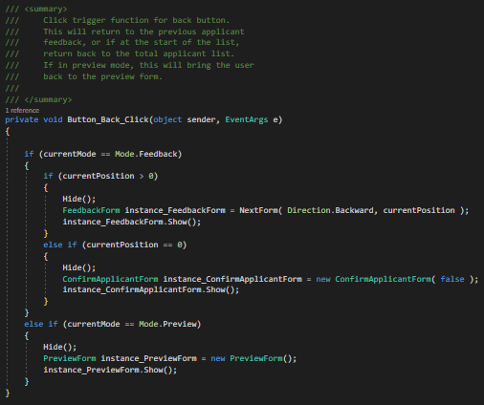

Figure 62: Button_Back_Click()

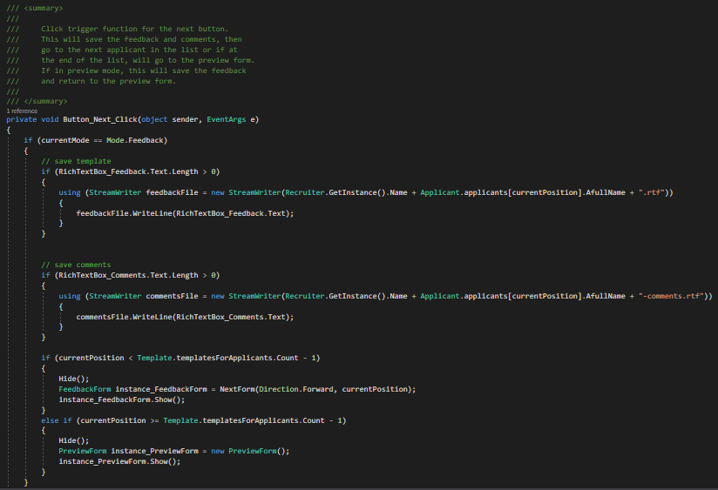

Figure 63: Button_Next_Click()

None of the code presented in Figure 64 comes from the author, who created the method. In this respect, its initial behaviour was to display the codes in the list paired up with their section. However, this implementation was entirely deleted by the other team members.

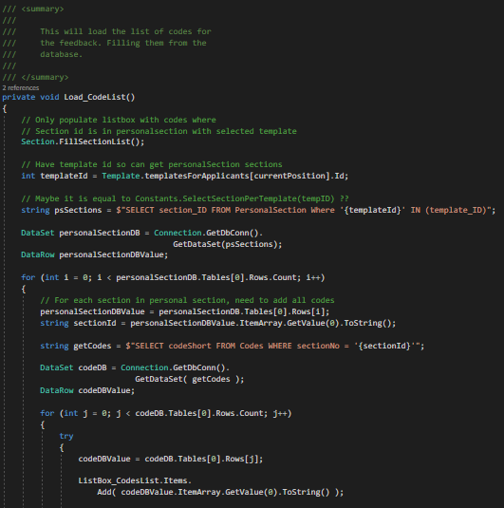

Figure 64: Load_CodeList()

### 3.2.2 Back-End Classes

**Applicant**

The class in Figure 65, was entirely created by the author, who implemented two lists which respectively hold the applicants added by the recruiter and the codes belonging to the single applicant.

The second list is a String type as it is used to accomplish the user stories implemented by the other team members. In this respect, the author initially created a Code type list.

The author also created read-only properties as applicant’s details can only be created in the constructor and, for security purposes, they are not expected to change later.

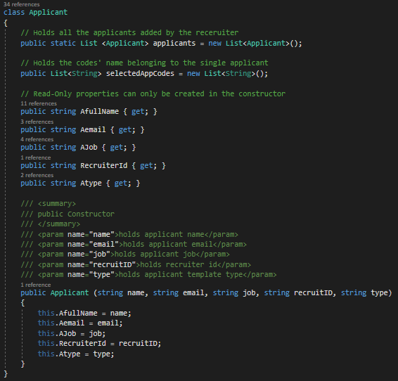

Figure 65: Applicant Class

**Code**

The class in Figure 66, was entirely created by the author, who implemented the list holding all the codes stored in the database. For the same reason mentioned in Section 3.2.2.1, the second list is a String type.

Additionally, since the codes’ attributes are expected to change in the program, they are implemented using both the getter and setter properties.

The author implemented a private constructor as they cannot be created anywhere in the system. Rather, it is called only in the FillCodeList() method, which aim is to retrieve data from the database, create a new instance and add it into the codeList.

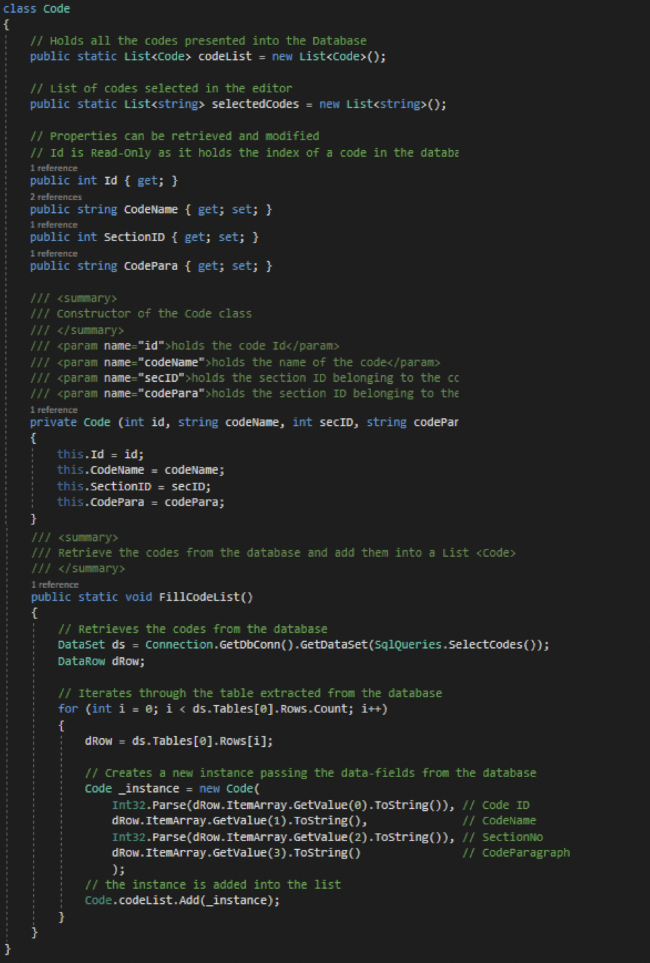

Figure 66: Code Class

**FeedbackClass**

The class in Figure 67 was entirely created by the author with the aim to contain all the logic needed in the FeedbackForm. Unfortunately, it is short as it has not been used by the other team members.

The “NextForm” method implemented by the author, is called in the FeedbackForm and, through a switch statement, it iterates through the list of templates selected for the applicants.

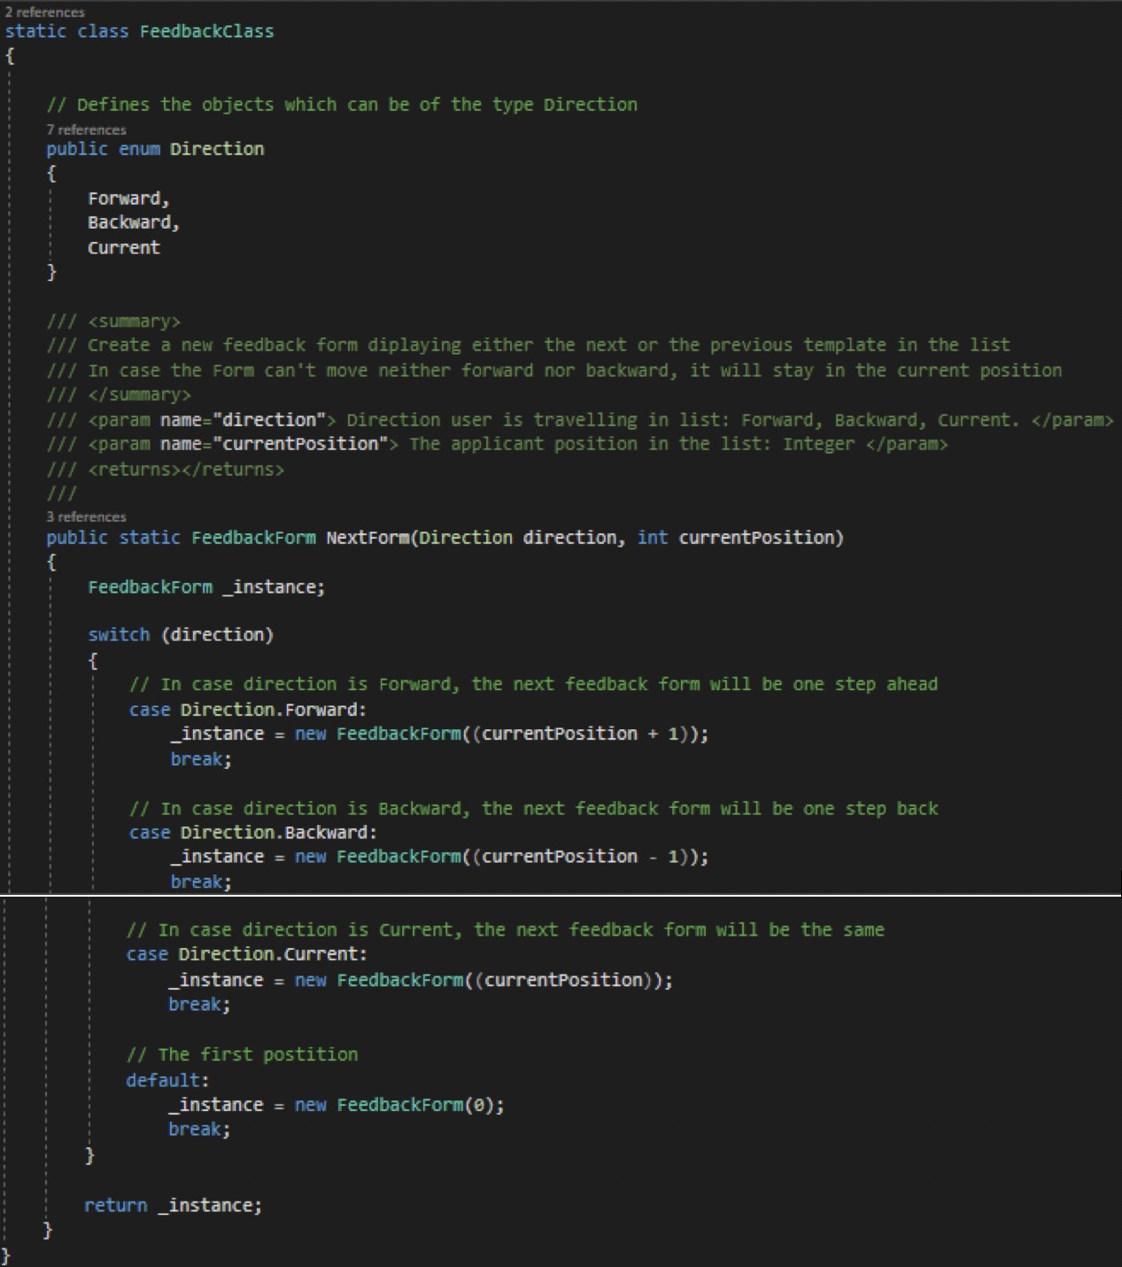

Figure 67: Feedback Class

**Section**

The class in Figure 68 was created by the author and used by the other team members.

Since section instances cannot be created unless they are added in the list, the author defined a private constructor and a private static instance, which is created only in the method FillSectionList().

#### 

Figure 68: Section Class

**SqlQueries**

As mentioned in Section 3.2.1, the author and the team created a class used to store all the queries asked to the database. In this way, it is possible to fix eventual bugs relating to the database.

Some of the methods created by the author are showed from Figure 69 to Figure 78.

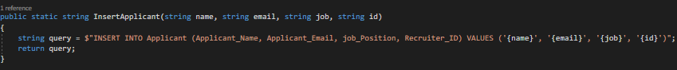

Figure 69: InsertApplicant()

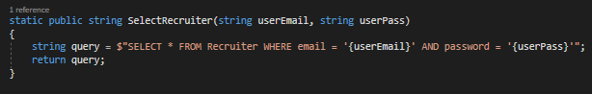

Figure 70: SelectRecruiter()

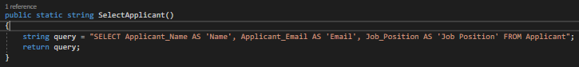

Figure 71: SelectApplicant()

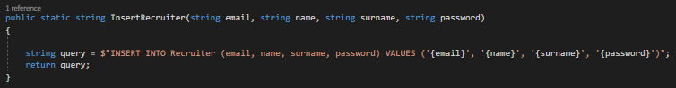

Figure 72: InsertRecruiter()

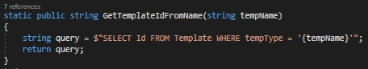

Figure 73: GetTemplateIdFromName()

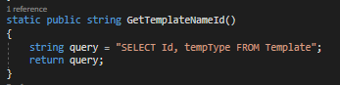

Figure 74: GetTemplateNameId()

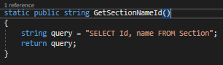

Figure 75: GetSectionNameId()

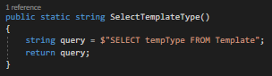

Figure 76: SelectTemplateType()

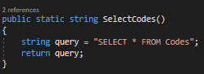

Figure 77: SelectCodes()

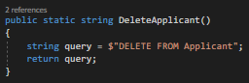

Figure 78: DeleteApplicant()

**Template**

The class was created by the author and used by the other team members.

In Figure 79, the author created two static template lists used to respectively hold the templates selected for the applicants and the templates in the database.

This class has two constructors and the author created only that one in Figure x. Two constructors are required because the database only stores the template id and the type, the header is then created based on the current variables defined by the recruiter and the applicant. Thus, while the first constructor is used when working in the DashForm, the second one is used when working in the EditorForm.

Read-Only Attributes were defined by the author as they are not expected to change once defined by the constructor.

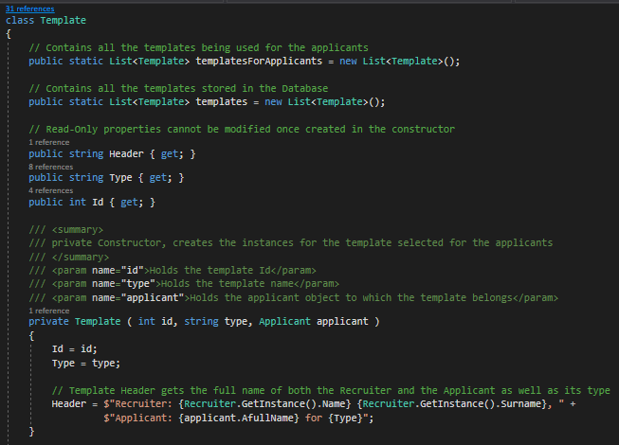

Figure 79: Template Class 1

In Figure 80, the author implemented both GenerateTemplatesForApplicant and GenerateTemplates methods. While the first one is used to fill the list containing the templates used to provide applicants with feedback, the second one fills the list containing all the templates stored in the database.

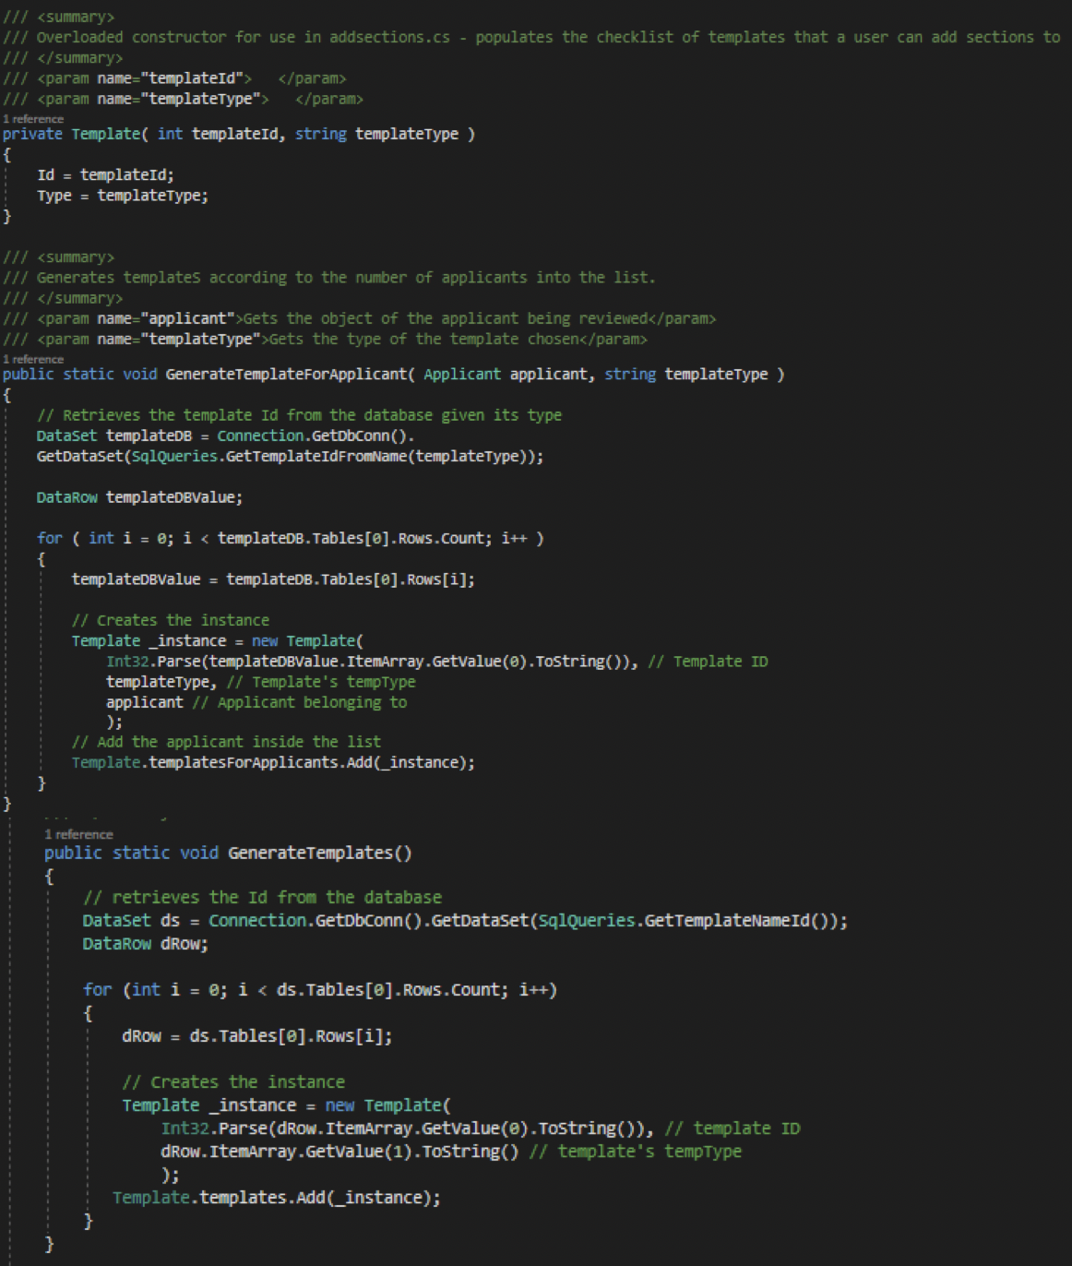

Figure 80: Template Class 2

**Recruiter**

The class in Figure 81-82 was entirely thought and implemented by the author.

Since the instance holds the information about the recruiter logging in the system, the instance should be created only if it has not been created before. To accomplish this security measure, the author defined a private static instance and a private constructor. The CreateInstance method creates the object only if the instance is equal to null and according to the principle of encapsulation, the instance can be retrieved only within the GetInstance method, which checks whether the object has been created.

Additionally, it has only read-only properties as they are not expected to change.

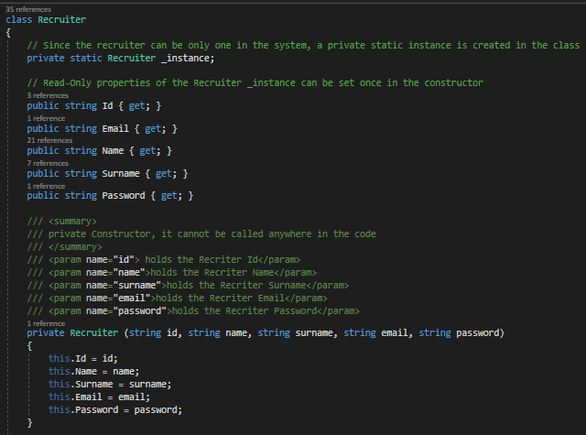

Figure 81: Recruiter Class 1

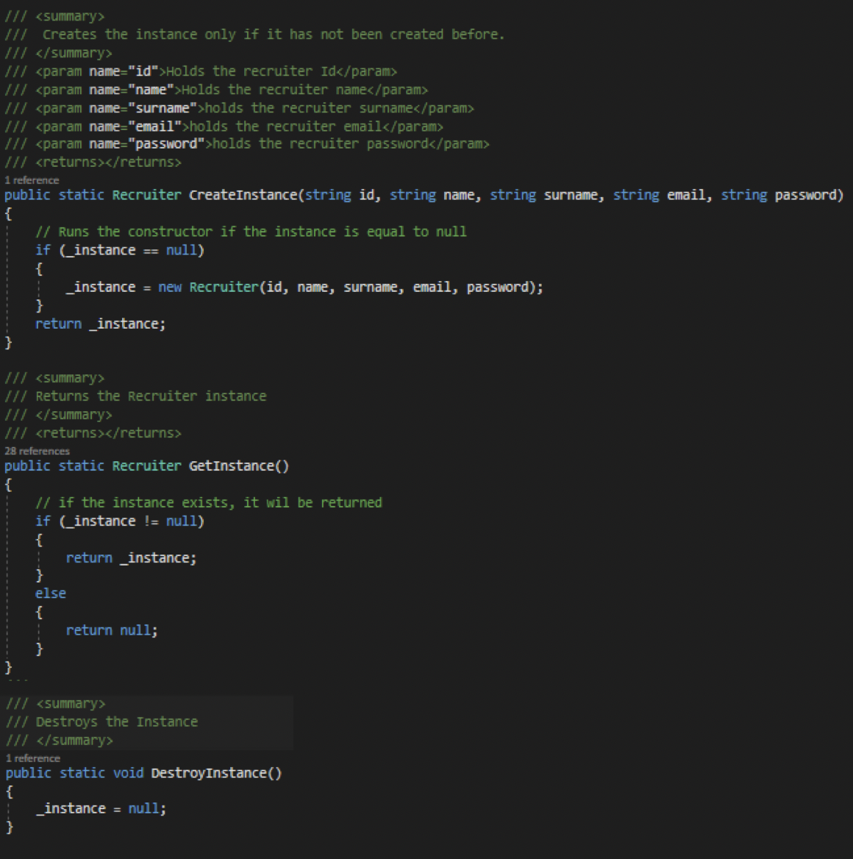

Figure 82: Recruiter Class 2

## 3.3 GitHub Personal Commits

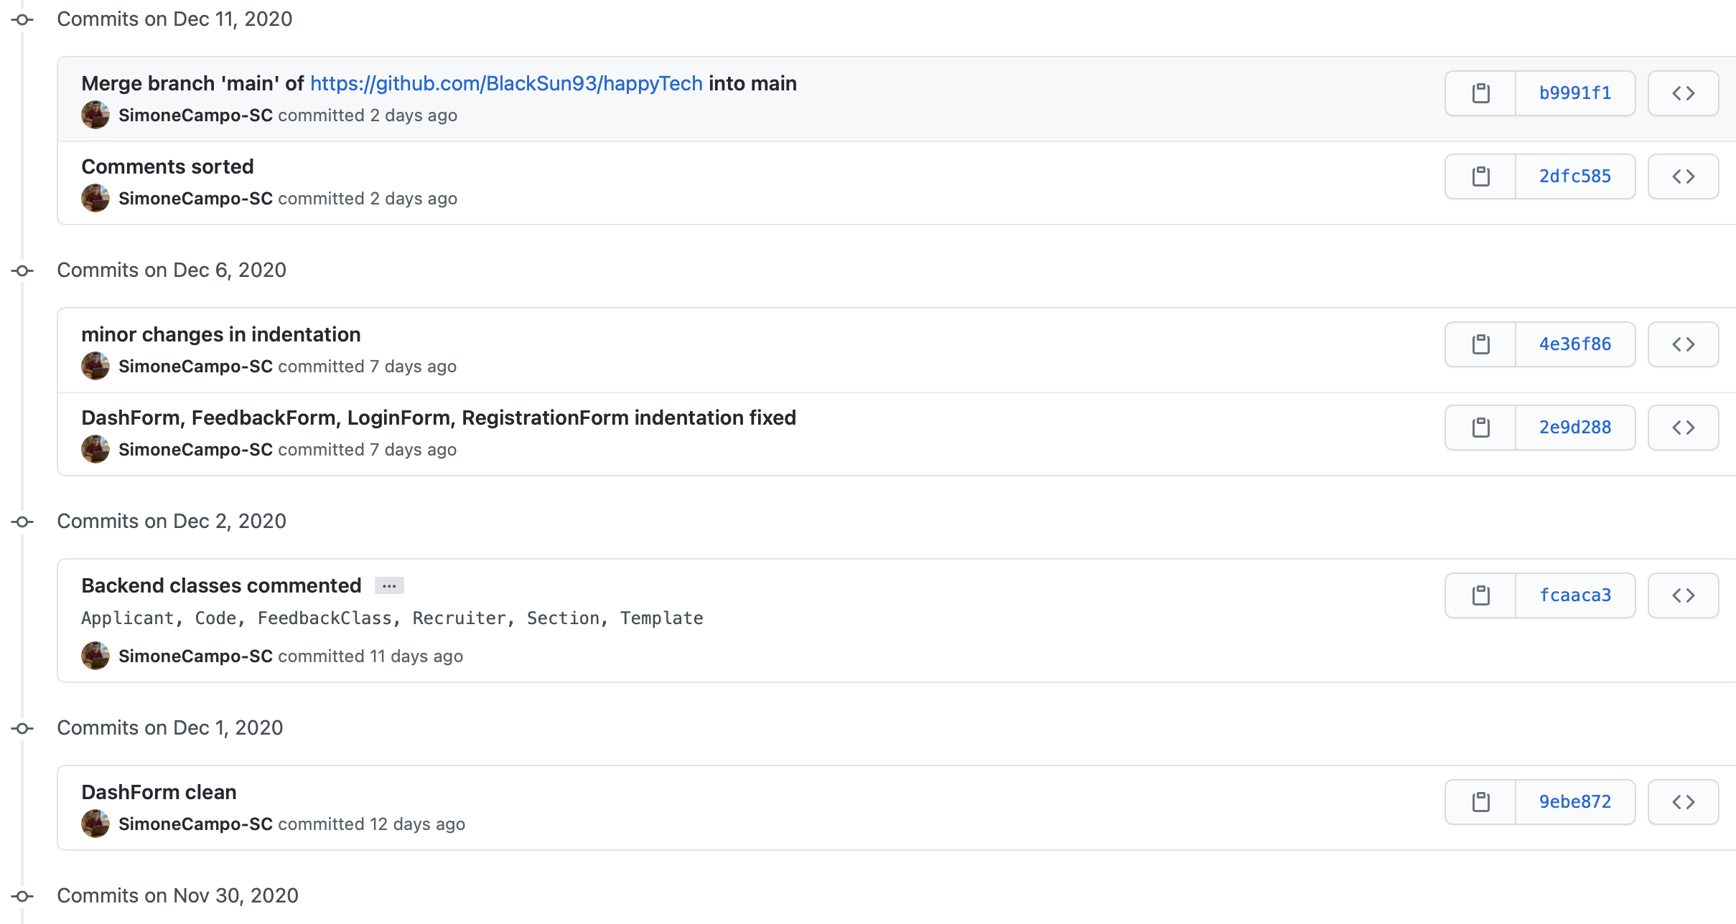

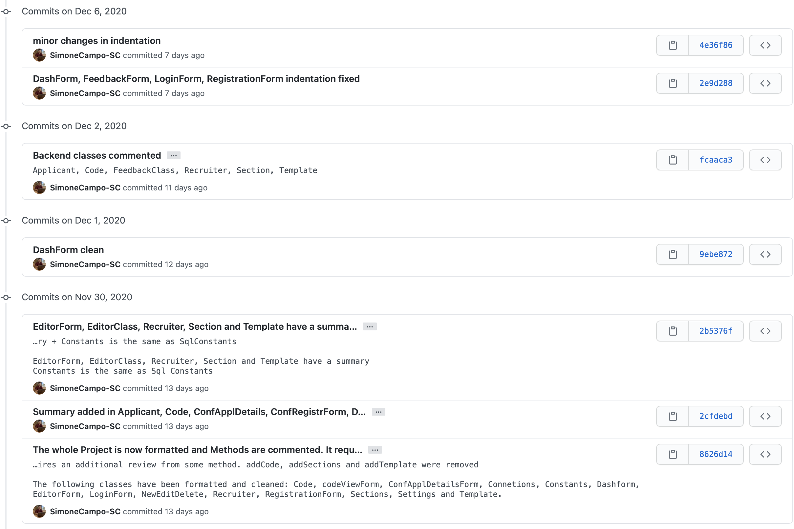

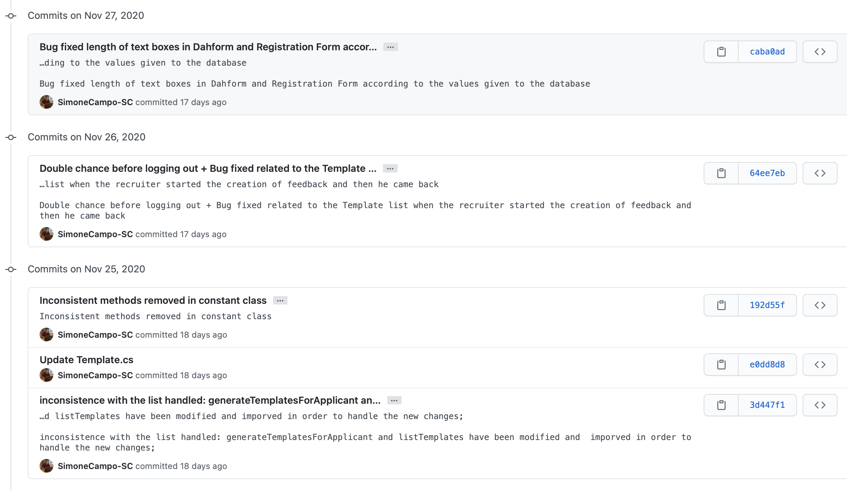

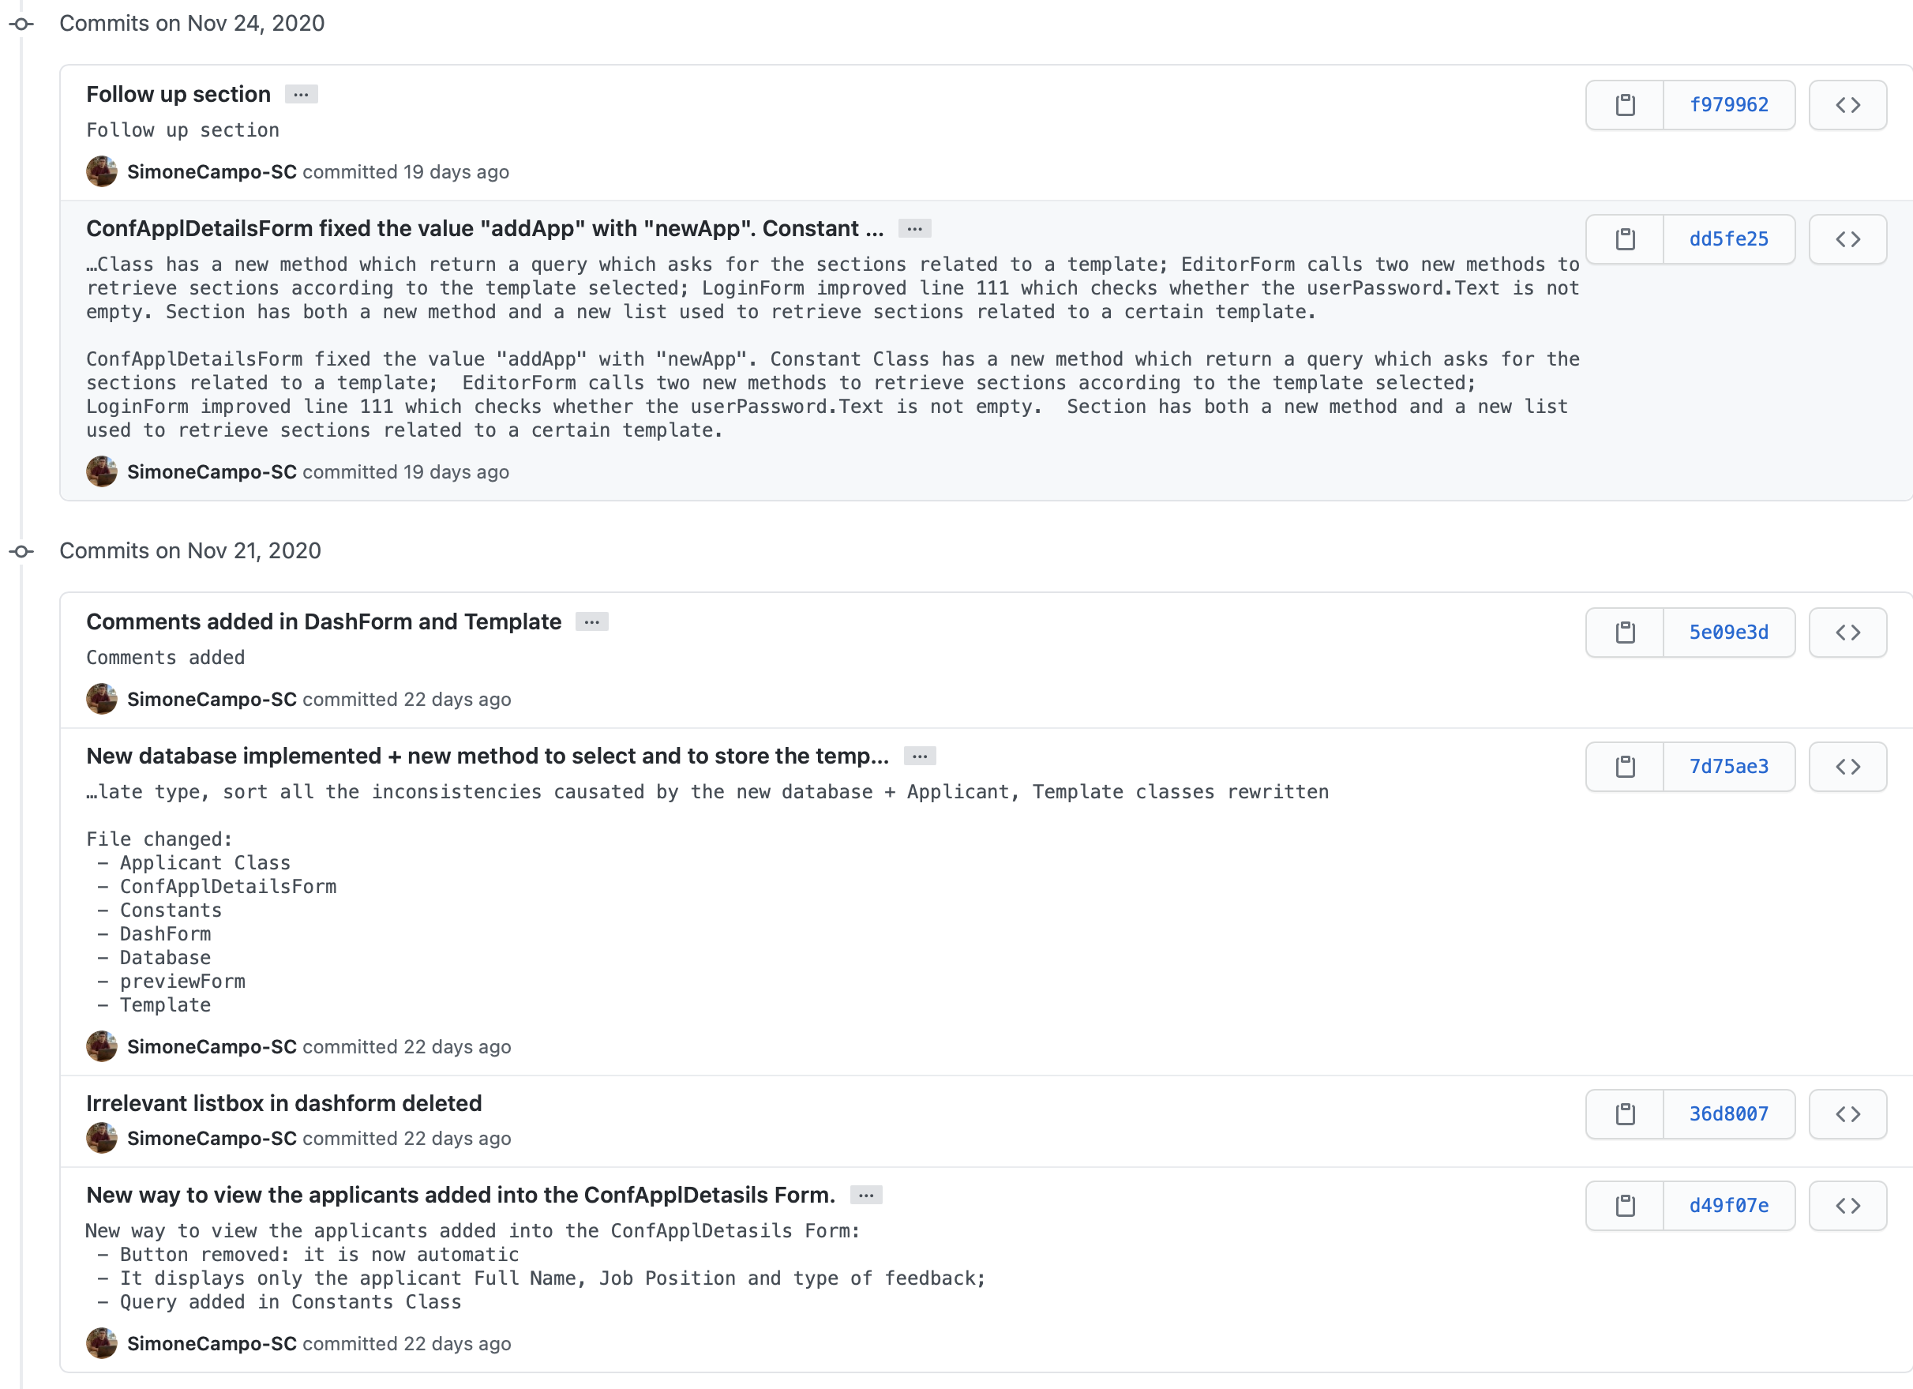

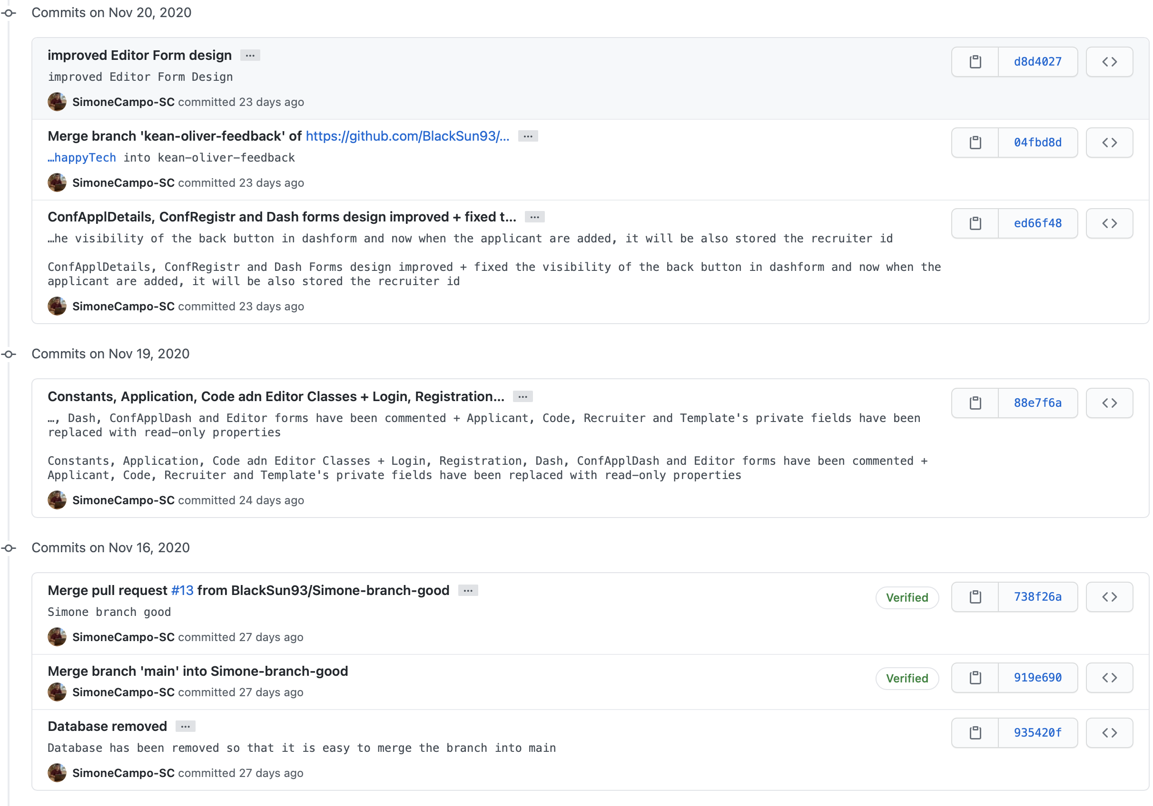

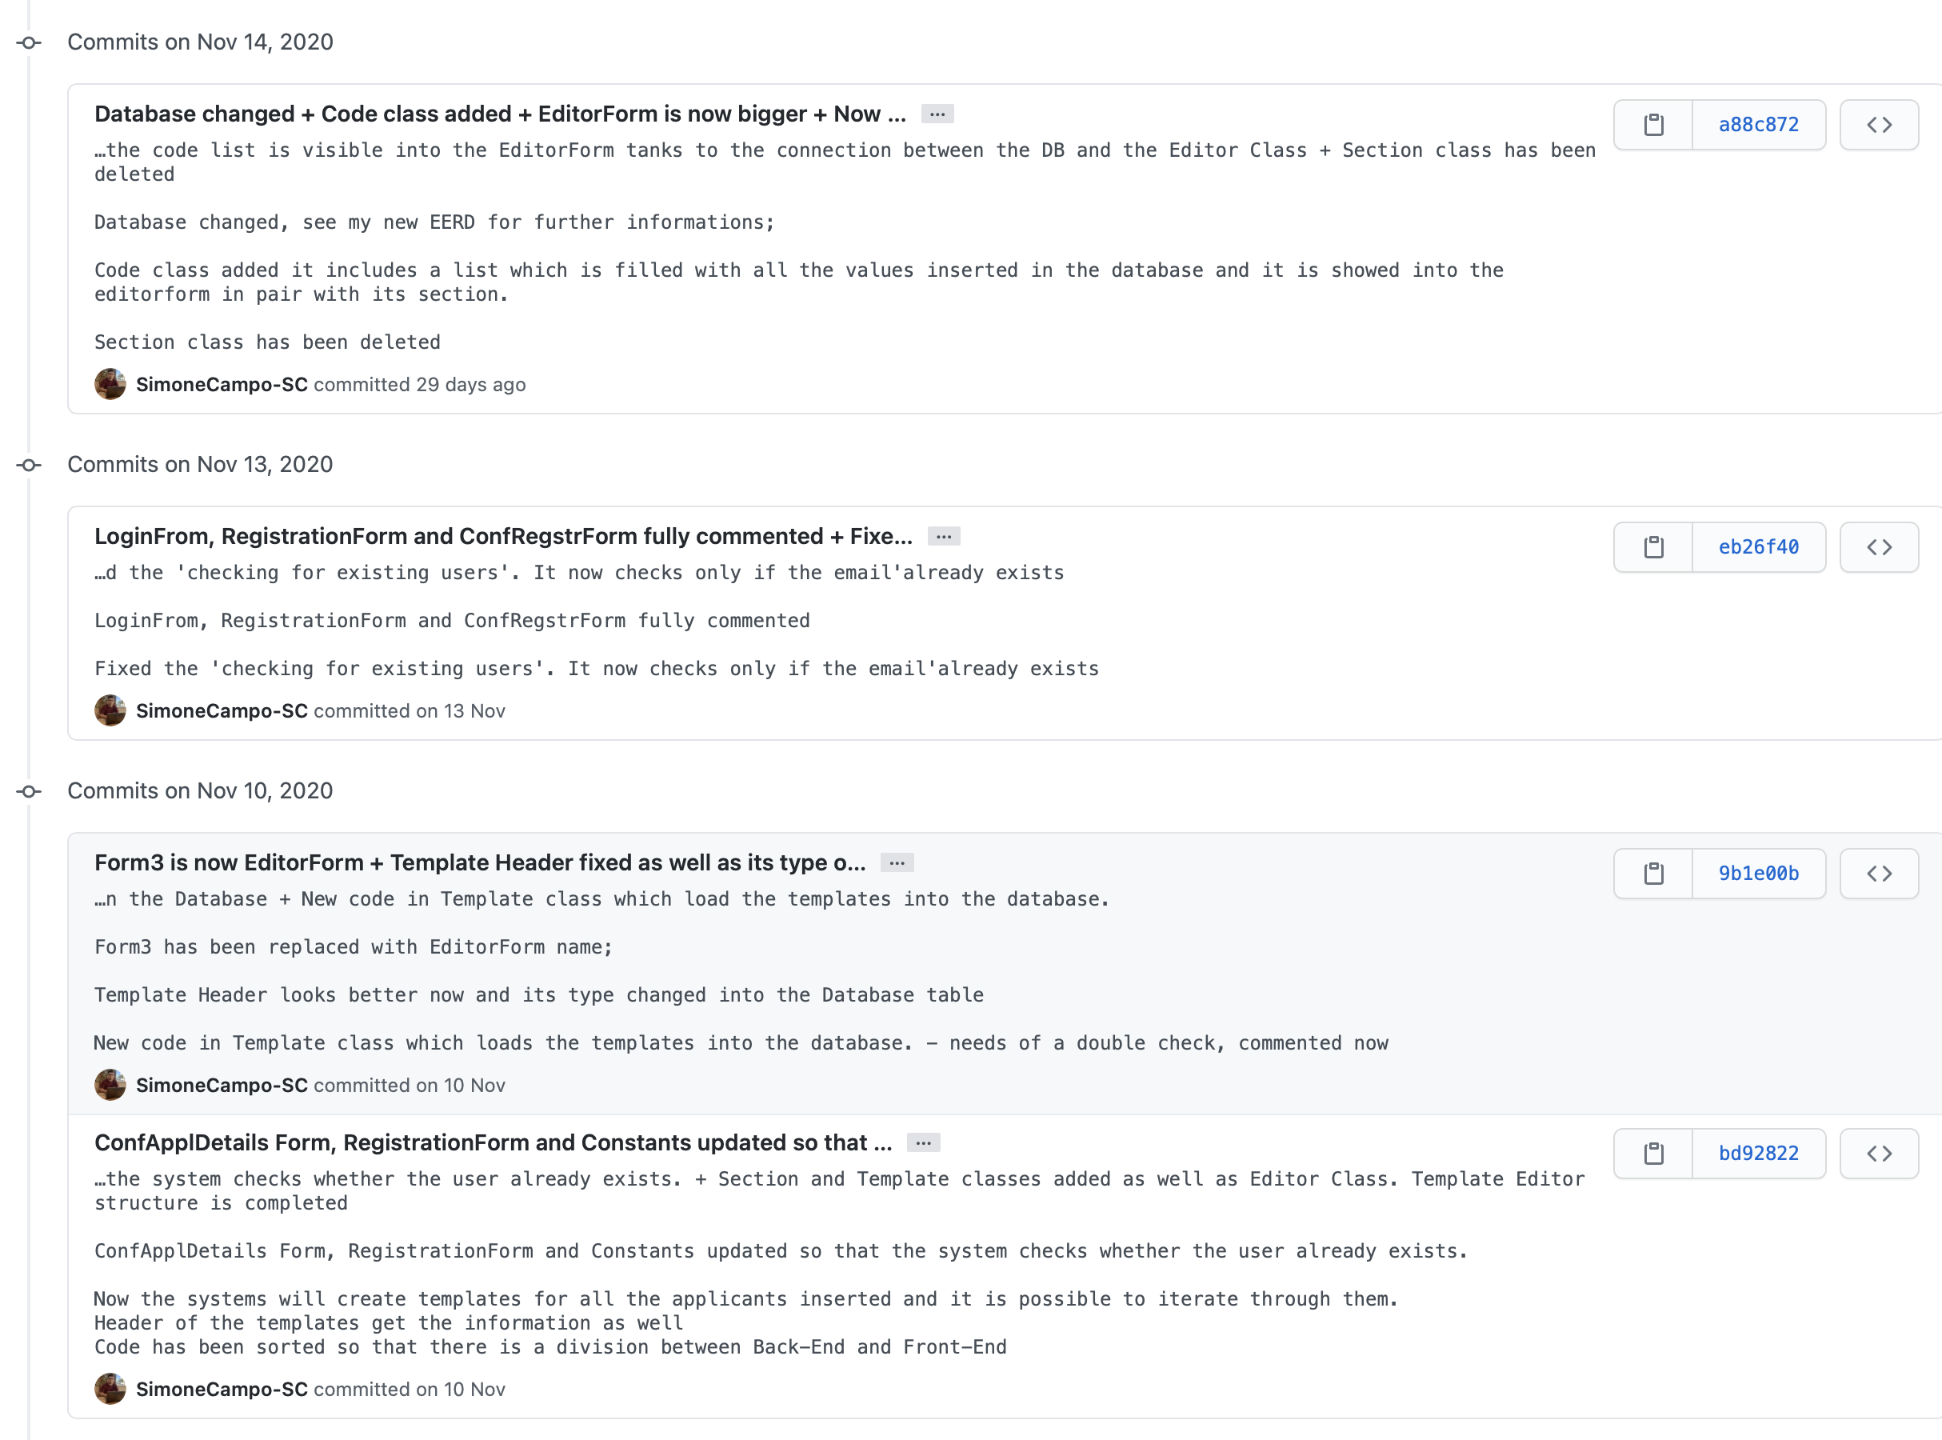

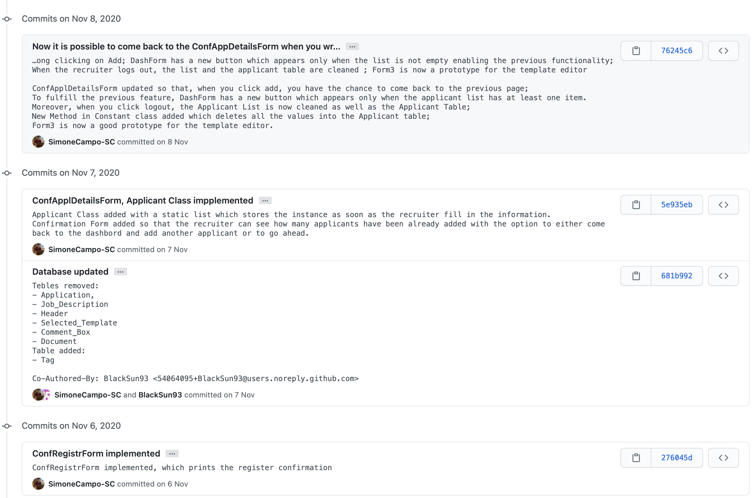

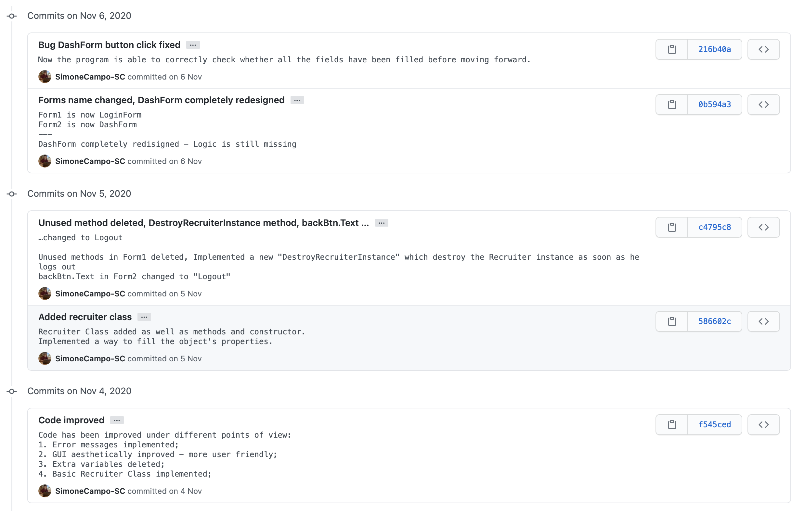

# 5. Testing

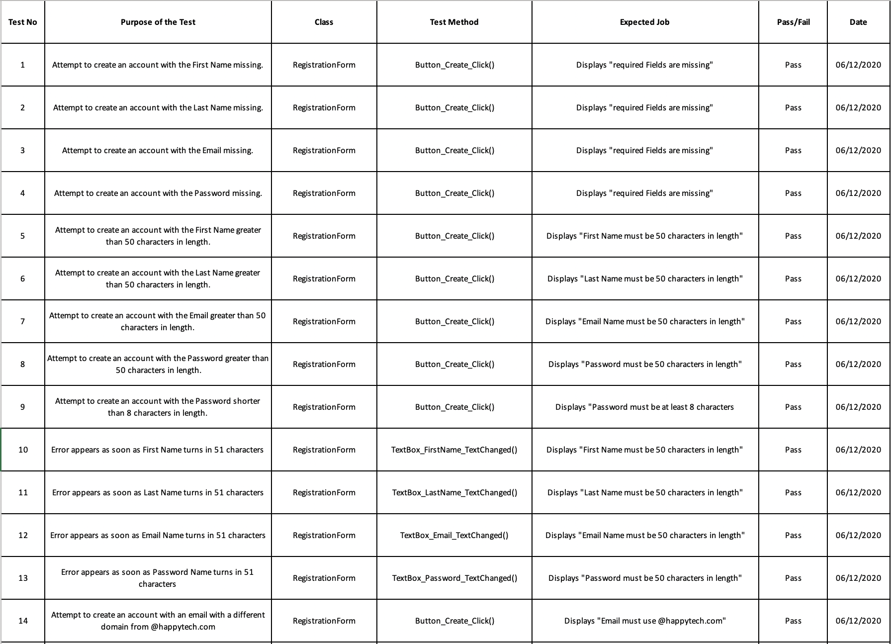

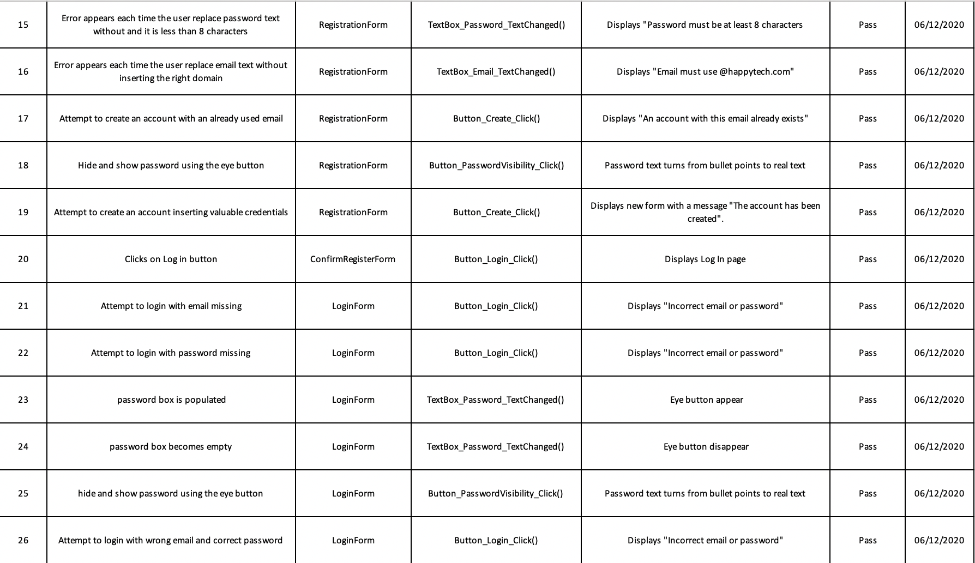

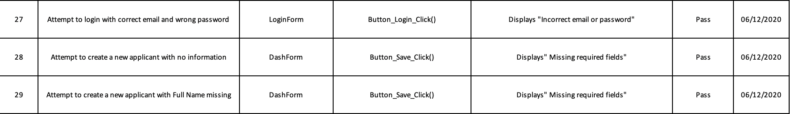

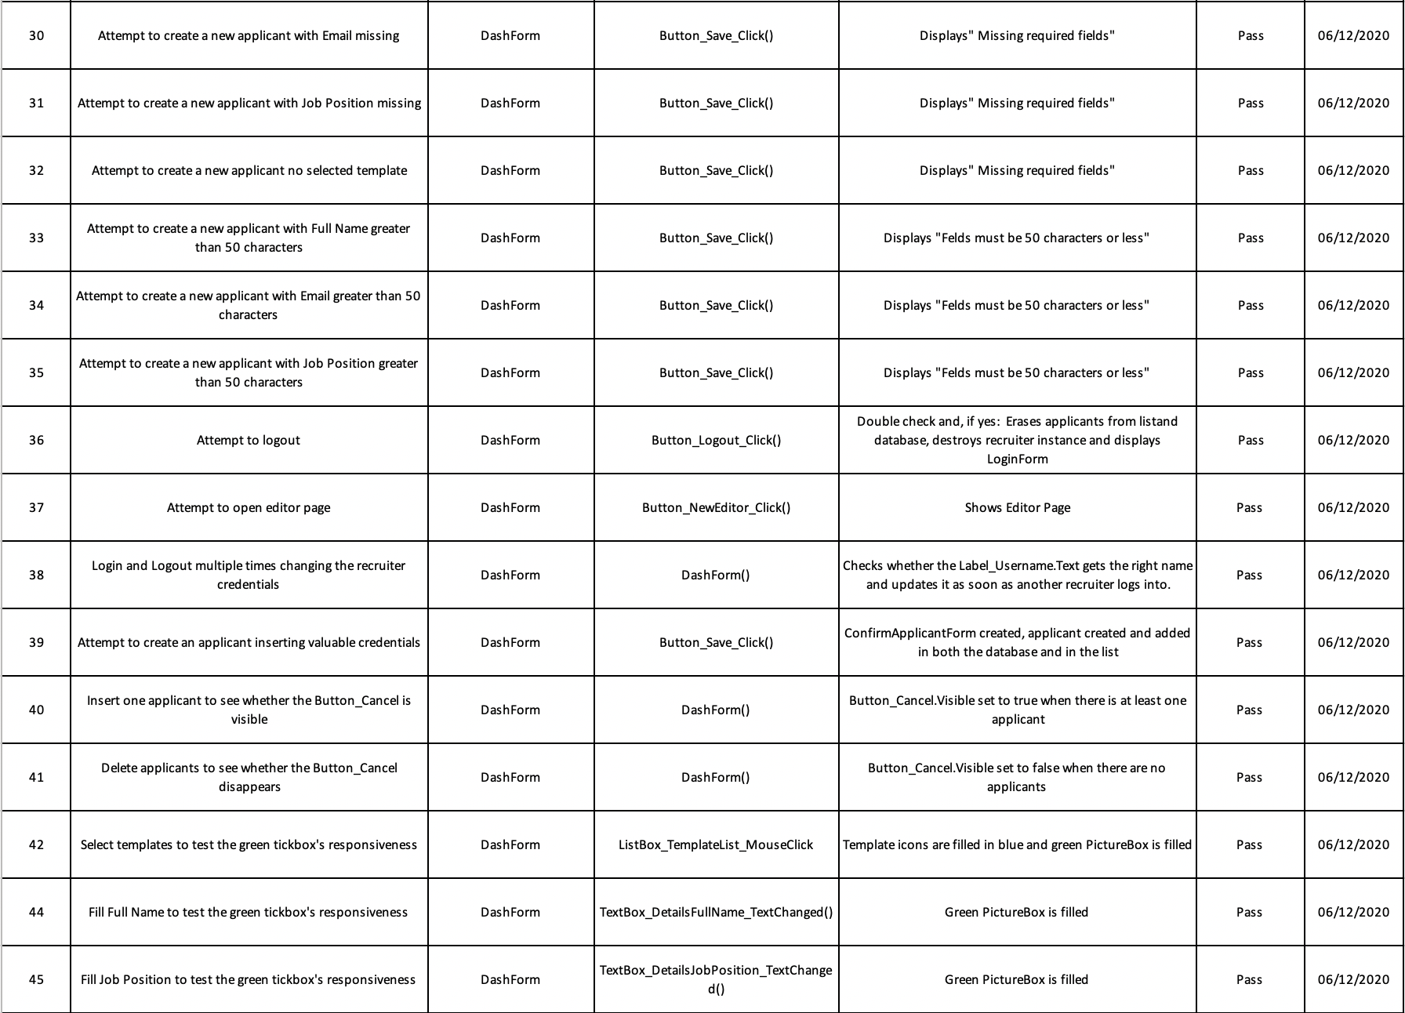

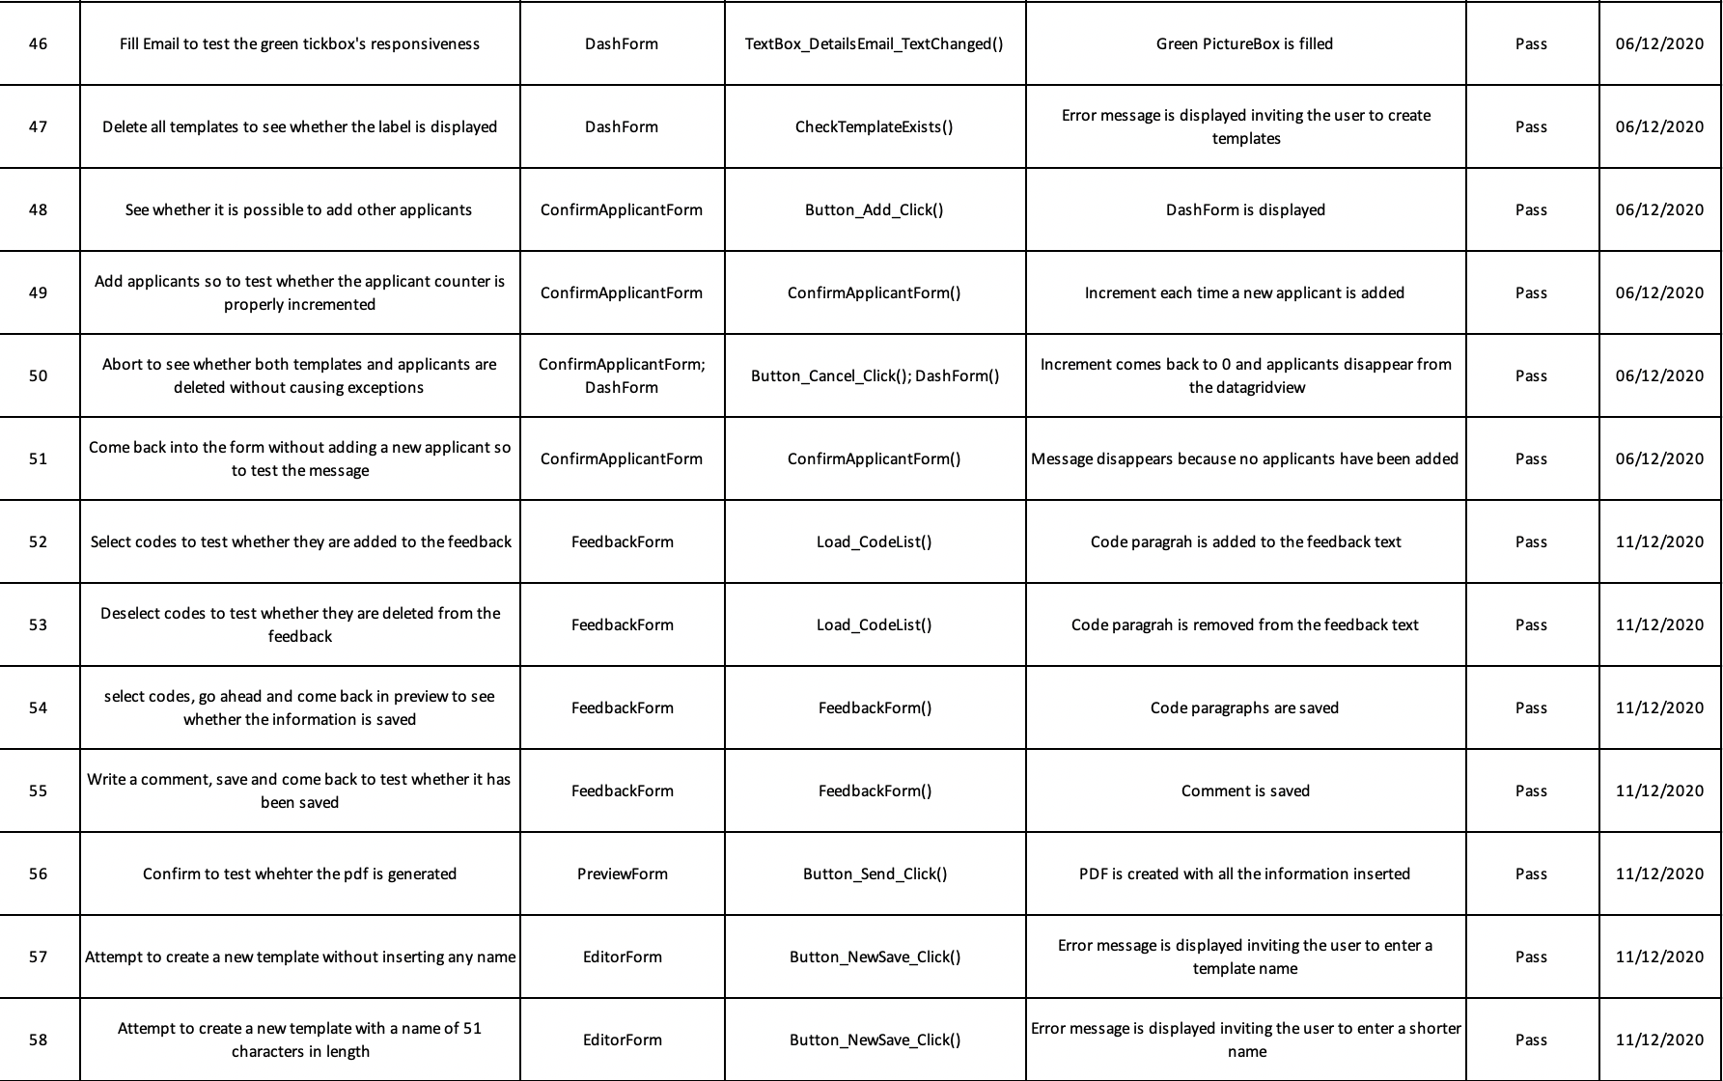



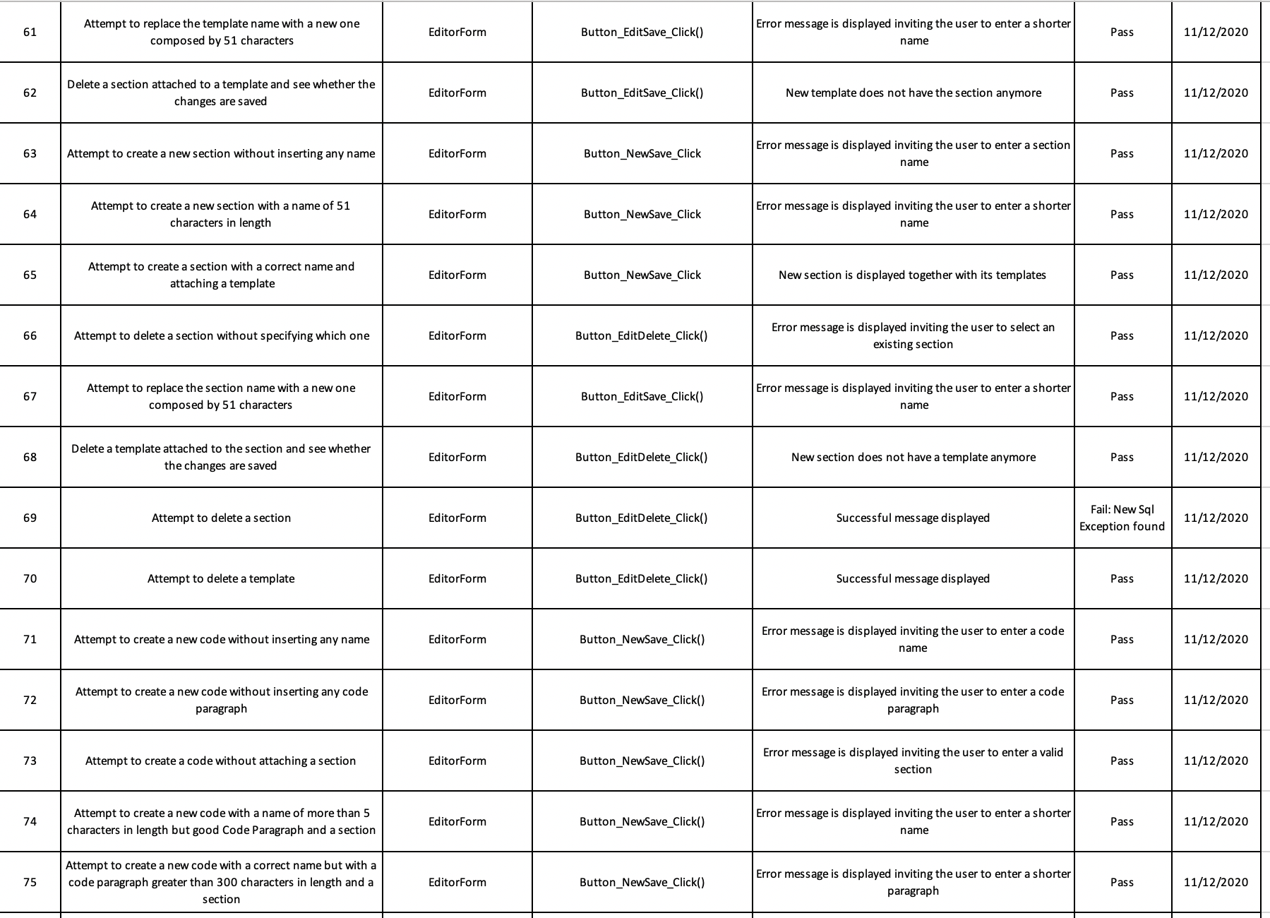

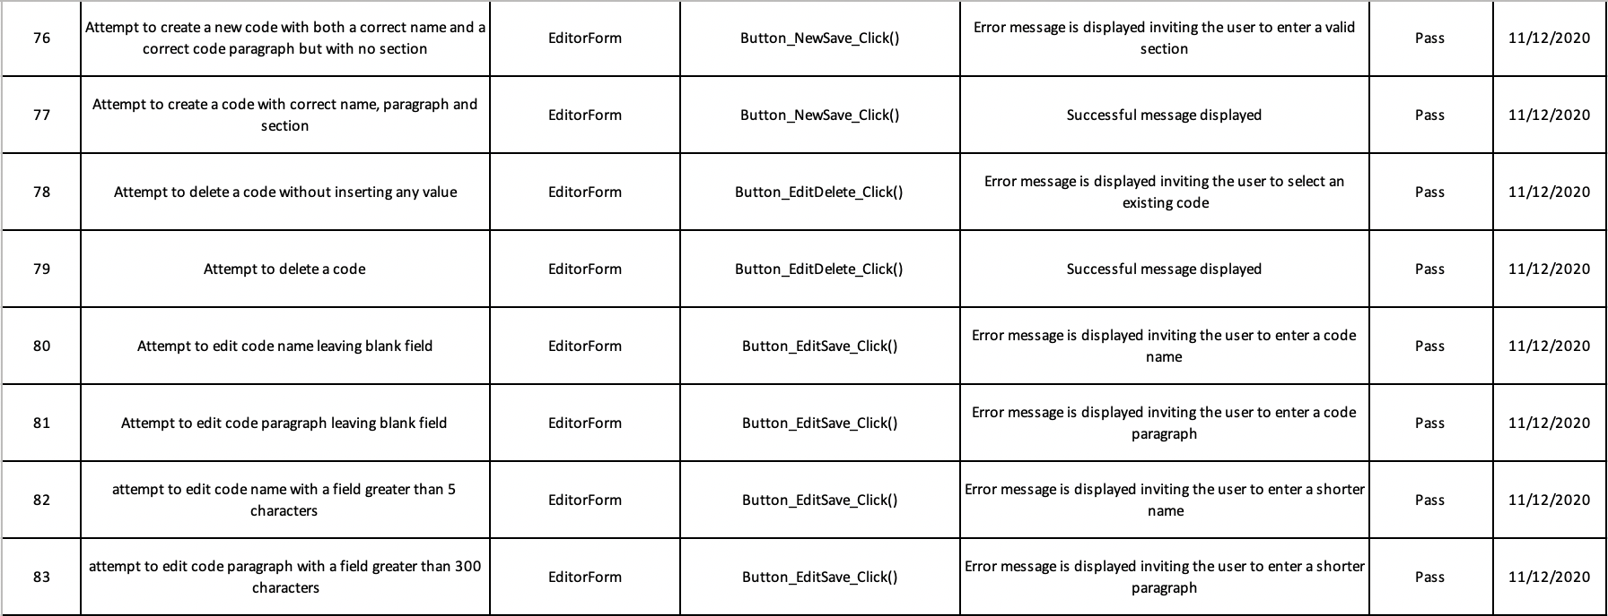

# 6. Plan of the Software Maintenance

Even though the application meets all the requirements listed in the case study, bugs are always prevalent in programs. However, because of manual testing, almost all identified bugs have been fixed. Several improvements can be implemented to make the application better:

1. The database stores sensitive information such as passwords and emails belonging to users. This information should be encrypted to protect against threats and attacks from malicious actors.
2. When providing feedback, the user can only see a list of codes. Once selected, the paragraph associated with the code will be automatically inserted into the feedback text. However, there is no way to see these paragraphs before choosing a code. Additionally, even though the application sorts codes by section, they are not grouped in the list, which may confuse the user.
3. As it stands, the application does not send emails to applicants. In future, this feature could be implemented by opening the recruiter’s default email application on their device and automatically sending emails using their login email.
4. The feedback table implemented in the database is not used because the application just creates PDF files. It would be an improvement by storing all the feedback into that table for analytical purposes.
5. The application allows the user to delete, change, or create the templates, sections, and codes. However, there are no security measure checks for if a user can do that. Therefore, an admin login would be useful to distinguish between recruiters and administrators so they can access extended features such as the editor page.
6. The current version performs several security checks during the registration process. However, it does not check whether the email, while containing the right domain, exists. It would be useful to implement a method that sends an automatic email to the email address so that the user can confirm it is correct.
7. Using Windows Forms, the application can only be executed on Windows machines. Therefore, a version for macOS would be needed.
8. The application has been developed in English and there is no way to switch language. If HappyTech is international, there needs to be a way to change the language.
9. Passwords are stored as plain text in the database. This needs to change by salting and hashing the passwords with SHA256 instead of MD5 as the latter is not cryptographically secure and is slower than the former (Roger Knapp, 2011). It is also important to have control over how many hashes are done and so further complexity is needed (Microsoft Corp, 2020). When a user logs in, their password will be hashed and cross-referenced with the hash in the database. If both matches, the login will be successful, otherwise it will fail.
10. Applicants should not be entered with the same full name, email, and job as another applicant as this can cause problems with applicant references and feedback files associated with them.
11. The file name structure of RTF and PDF files need to change to accommodate applicants with the same full name, which could be an occurrence in the application. A proposed file name structure could be:

*RecruiterName_Type_ApplicantName_DateTimeNow.filetype*

*AndrewGreyworth_CV_AndreaJameson_20201212-140603.pdf*

This will allow applicants that have the same full name and application type by the same recruiter to have separate files as these cannot be created at the same time.

1. SQL statements should be parameterised. Currently, our application allows user input directly into SQL statements, which leaves our program vulnerable to SQL injection. This also means users cannot enter special characters (such as ` ’ ”) without the program crashing. Parameterised queries ensure the user does not have access to the SQL to be executed on the database.
2. The EditorForm and SqlQueries classes need to be broken up as they are too big. EditorForm should be broken up into code dealing with the frontend and backend as well as methods for codes, sections, and templates. SqlQueries can also be broken up into smaller classes that contain only the SQL for the tables they interact with (codes, sections, templates, applicants, etc).

# Conclusion

This module helped me to grow from through different aspects. Since my biggest dream is to become a Software Engineer, I immediately started working with particular interest on the project.

At the beginning, I felt daunted as I had never created an application using Windows Forms and have never programmed in a group using GitHub.

Luckily, I was part of an amazing group, in which we supported and helped each other and stuck to the deadlines. We had a common goal: to excel.

Thanks to this experience, next to getting a better and deeper understanding of what the Software Development Lifecycle is and how to develop according to the Agile methodology, I also learnt to listen to others and to split the workload according to well-defined roles.

At first, we spent several hours together on Visual Studio learning how to use the tools in the toolbox and, once we acquired the necessary knowledge, we started creating our project.

Despite the Covid-19 pandemic playing against our odds, we successfully managed to do a great teamwork and most importantly, to have fun.

Both the project and the report itself are the result of passion and dedication of turning fun in a job.

I am certain we will continue to work together on other projects. It has been the first of many upcoming ones.

# References

1. ScrumAlliance, 2020. *The Agile Manifesto.* [online] Available at: <<https://www.scrumalliance.org/resources/agile-manifesto> > [Accessed 28 September 2020].
2. Jasper van der Hoek, 2018. *Pursuing a Full Agile Software Development Lifecycle.* [online] Available at: <<https://www.mendix.com/blog/pursuing-a-full-agile-software-lifecycle/>> [Accessed 28 September 2020].
3. Mountain Goat Software, 2020. *What is a user story?.* [online] Available at: <<https://www.mountaingoatsoftware.com/agile/user-stories>> [Accessed 2 October 2020].
4. Visual Paradigm, 2020. *What is Use Case Diagram?*. [online] Available at:

<<https://www.visual-paradigm.com/guide/uml-unified-modeling-language/what-is-use-case-diagram/>> [Accessed 2 October 2020].

1. tutorialspoint, 2020. *UML – Class Diagram*. [online] Available at: <<https://www.tutorialspoint.com/uml/uml_class_diagram.htm>> [Accessed 2 October 2020].
2. Lucidchart, 2020. *UML Sequence Diagram Tutorial*. Available at: <<https://www.lucidchart.com/pages/uml-sequence-diagram>> [Accessed 2 October 2020].
3. Matthew Heusser, 2020. *Unstable User Interfaces*. Available at:

<<https://smartbear.com/learn/what-is-manual-testing/>> [Accessed 13 November 2020].

1. Tomas, 2019. *Pros and Cons of Manual Testing*. Available at:

<<https://kroneit.com/manual-testing-vs-test-automation-pros-and-cons-quick-overview/>> [Accessed 13 November 2020].

1. Roger Knapp, 2011. *Another example of how to store a salted password hash.* Available at:

<<http://csharptest.net/470/another-example-of-how-to-store-a-salted-password-hash/>> [Accessed 12 December 2020].

1. Microsoft Corp, 2020. *Rfc2898DeriveBytes Class*. Available at: <<https://docs.microsoft.com/en-us/dotnet/api/system.security.cryptography.rfc2898derivebytes?view=net-5.0>> [Accessed 12 December 2020].